
Datasheet
No.: D7GT0237(TWO SIDE)-120 240-up: 60° down: 6°
Version: 2025-11-27-02
ITEM: D7GT0237(TWO SIDE) | INPUT VOLTAGE(V)  120 240 | LENS  N/A |  | LENS DEGREE(°)θ1/2  up: 60° down: 6° |  | CCT  3000K
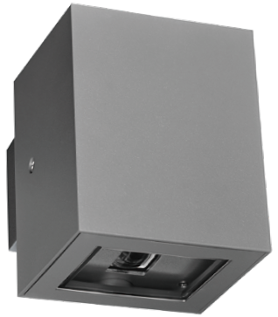  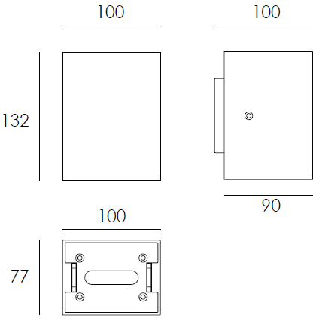 |  |  | LIGHT SOURCE |  | 2×3W
 |  |  | CONSUMPTION(W) |  | 120=10.7 240=10.5
 |  |  | OPERATING CURRENT(MA) |  | 120=91 240=52
 |  |  | POWER FACTOR(PF) |  | 0.505
 |  |  | LUMINANCE(LM) |  | up:210 down:75
 |  |  | COLOR RENDERING INDEX |  | RA: 80
 |  |  | IK RATING |  | 08
 |  |  | IP RATING |  | 65
PRODUCT SPECIFICATIONS
HOUSING | 12# Die-casting aluminum finishing or powder painting T=60-80µm.  Adhesion of ISO class 1/ASTM class 4B
LIGHT WINDOW | UVstop & Fireproof PC T=3mm
LED TYPE | SMD
GASKET | Tooling shaped seal
DRIVER | Main voltage 100V-240V built-in driver
OPERATING TEMPERATURE | -20°C-40°C
POWER CABLE | Outside of luminaire  120V/240V: H05RN-F 3×1.0mm², L=0.3m
DIMMING SUPPORT | Triac PWM Available 1-10V Dali Customized
DIAGRAM OF INSTRUCTION
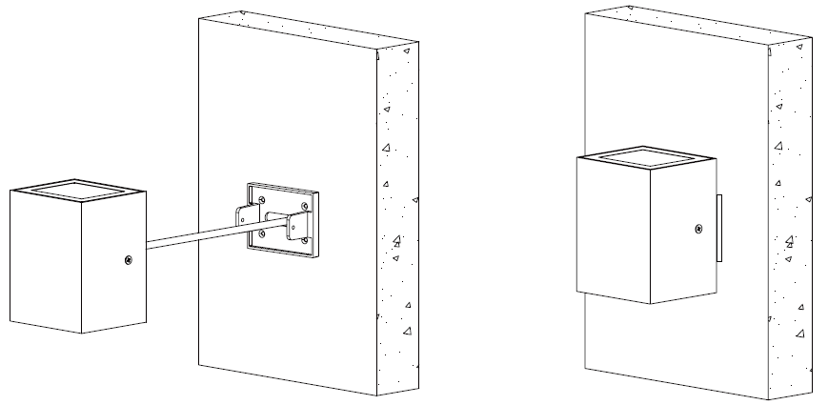
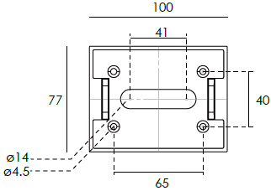

PAINTING COLOR
  Primary   |       Secondary      

PHOTOMETRIC
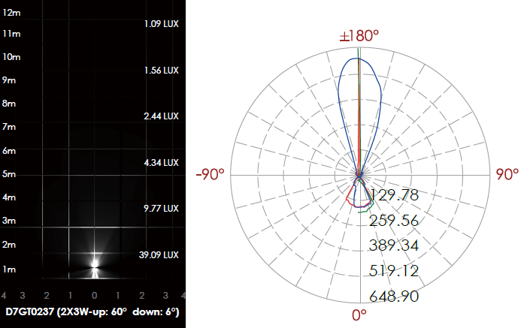

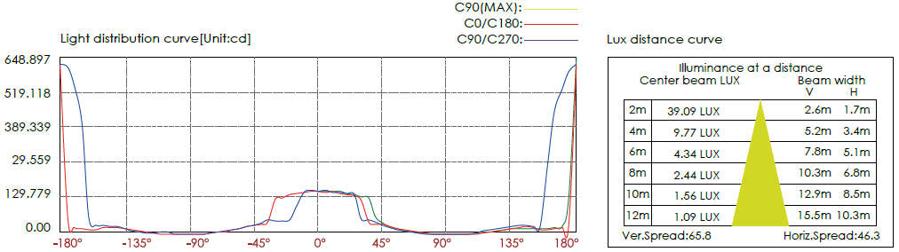

CERTIFICATES


