
Datasheet
No.: D7GQ0126(ONE SIDE)-DC 24-60°
Version: 2025-11-27-02
ITEM: D7GQ0126(ONE SIDE) | INPUT VOLTAGE(V)  DC 24 | LENS  N/A |  | LENS DEGREE(°)θ1/2  60° |  | CCT  3000K
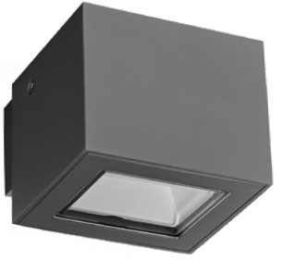  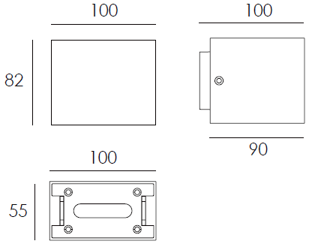 |  | LIGHT SOURCE |  |  | 1×6W
 |  | CONSUMPTION(W) |  |  | 6.5
 |  | OPERATING CURRENT(MA) |  |  | 270
 |  | POWER FACTOR(PF) |  |  | 1
 |  | LUMINANCE(LM) |  |  | 580
 |  | COLOR RENDERING INDEX |  |  | RA: 80
 |  | IK RATING |  |  | 08
 |  | IP RATING |  |  | 65
PRODUCT SPECIFICATIONS
HOUSING | 12# Die-casting aluminum finishing or powder painting T=60-80µm.  Adhesion of ISO class 1/ASTM class 4B
LIGHT WINDOW | UVstop & Fireproof PC T=3mm
LED TYPE | SMD
GASKET | Tooling shaped sea
DRIVER | Main voltage 100V-240V built-in driver
OPERATING TEMPERATURE | -20°C-40°C
POWER CABLE | Outside of luminaire 12V/24V: H05RN-F 2×1.0mm², L=0.3m
DIAGRAM OF INSTRUCTION
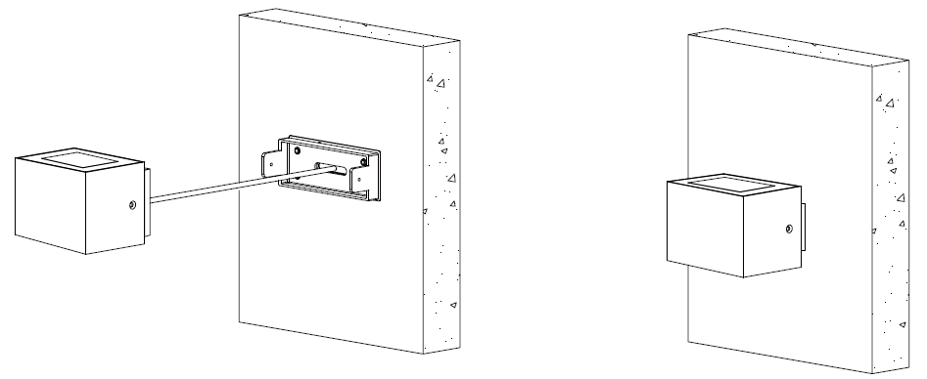
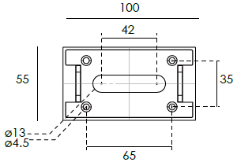

PAINTING COLOR
  Regular   |       Secondary      

PHOTOMETRIC
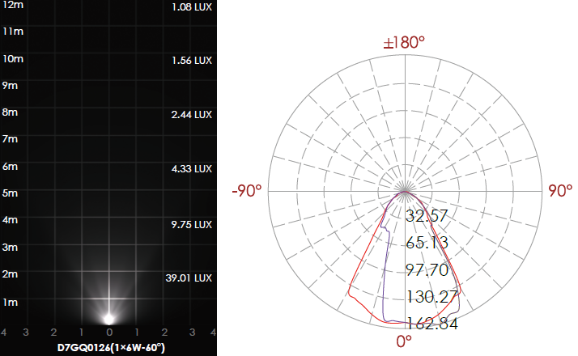

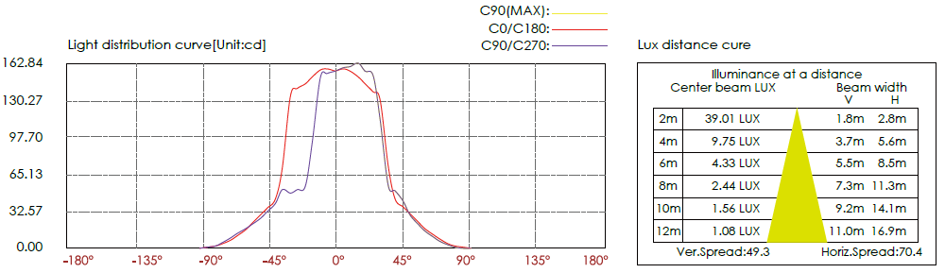

CERTIFICATES


