
Datasheet
No.: B5AH0126-DC 24-B106-24°
Version: 2025-11-18-02
ITEM: B5AH0126 | INPUT VOLTAGE(V)  DC 24 | LENS  B106 | LENS DEGREE(°)θ1/2  24° |  | CCT  3000K
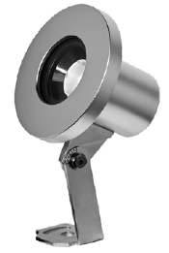  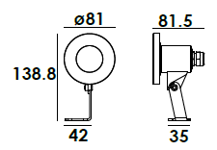 |  | LIGHT SOURCE |  | 1×6W
 |  | CONSUMPTION(W) |  | 7.4
 |  | OPERATING CURRENT(MA) |  | 305
 |  | POWER FACTOR(PF) |  | 1
 |  | LUMINANCE(LM) |  | 520
 |  | COLOR RENDERING INDEX |  | RA: 80
 |  | IK RATING |  | 08
 |  | IP RATING |  | 68
PRODUCT SPECIFICATIONS
FRONT COVER | Hard chromeplated molding shaped stainless steel SUS 316#
HOUSING | Hard chromeplated molding shaped stainless steel SUS 316L#
LIGHT WINDOW | Step Tempered glass.T=8mm
WATERPROOF SEAL | EPDM gasket
LENS | Separate OPTICS lens efficiency≥85%
LED TYPE | COB
CABLE GLAND | IP68 M1 6a copper with nickel-coated
PCB | Excellent heat conductivity aluminum.coefficient of heat Conductivity≥2.0w/mk
LED DRIVER | Constant Voltage Input,Constant Current Output
POWER CABLE OPTIONAL | Outside of luminaire  H07RN-F 2×1.0mm2 with water-stopper, L=1m, 3m, 5m
OPERATING TEMPERATURE | Temperature of water between -20˚C~40˚C less than 1 meter depth
WATER PROOF SOLUTION
A. Water-Stopper(Included)
IP-68 water-stopper is added in the end of luminaires as standard
assembly which is also an important system for water resistance.

B. IP68 Jiffy quick plug/socket connector(Optional)
IP-68 connector is as an Optional assembly and ensures that water vapor
will not enter into luminaires directly.
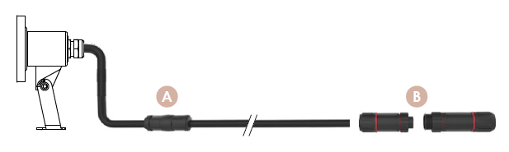

ADJUSTABLE BEAM DIRECTION
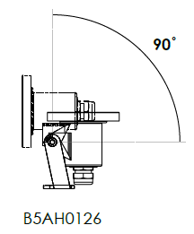

PHOTOMETRIC
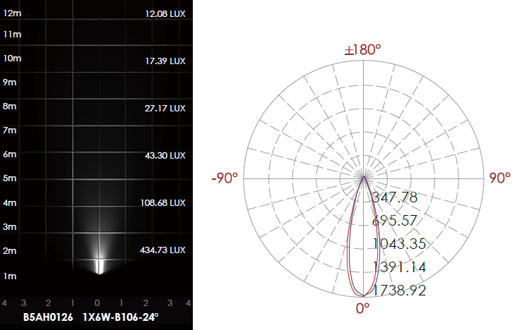

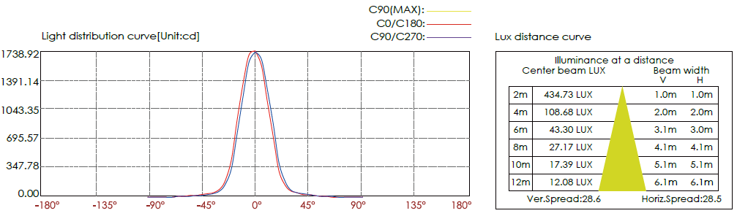

CERTIFICATES


