
Datasheet
No.: C4A0159A-DC 24-C9-45°+35°
Version: 2025-11-18-02
ITEM: C4A0159A | INPUT VOLTAGE(V)  DC 24 | LENS  C9 | LENS DEGREE(°)θ1/2  45°+35° |  | CCT  3000K
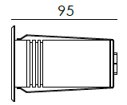  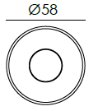  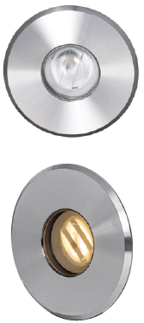  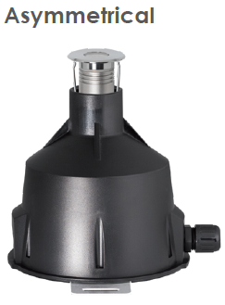 |  | LIGHT SOURCE |  | 1×3.6W
 |  | CONSUMPTION(W) |  | 5
 |  | OPERATING CURRENT(MA) |  | 210
 |  | POWER FACTOR(PF) |  | 1
 |  | LUMINANCE(LM) |  | CW=416 WW=316
 |  | COLOR RENDERING INDEX |  | RA: 80
 |  | IK RATING |  | 08
 |  | IP RATING |  | 68
PRODUCT SPECIFICATIONS
FRONT COVER & HOUSING | Hard chromeplated molding shaped stainless steel SUS 316#
LIGHT WINDOW | Step Tempered glass. T=8mm
GASKET | Silicone Gasket
LENS | OPTICS lens, efficiency≥85%
LED TYPE | SMD
PCB | Excellent heat conductivity aluminum.coefficient of heat Conductivity≥2.0w/mk
LED DRIVER | Constant Voltage Input, Constant Current Output
POWER CABLE OPTIONAL | Outside of luminaire  H07RN-F 2×1.0mm2 with water-stopper, L=3m, 5m
GLASS PRESSURE CAPACITY | 8932kgs
OPERATING TEMPERATURE | -20˚C~40˚C
DIMMING SUPPORT | Triac PWM Available 1-10V Dali Customized
RECESSED SLEEEVE | 115# PC/ABS ALLOYS, with 304 stainless steel bottom plate

WATER PROOF SOLUTION
A. Water-Stopper(Included)
IP-68 water-stopper is added in the end of luminaires as standard
assembly which is also an important system for water resistance.

B. IP68 Jiffy quick plug/socket connector(Optional)
IP-68 connector is as an Optional assembly and ensures that water vapor
will not enter into luminaires directly.
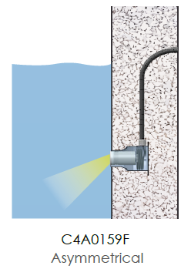
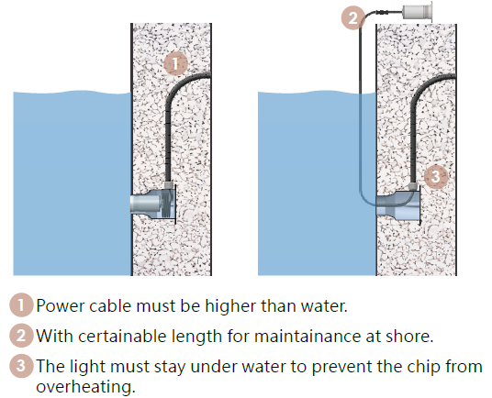
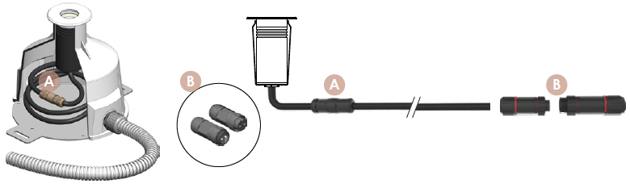
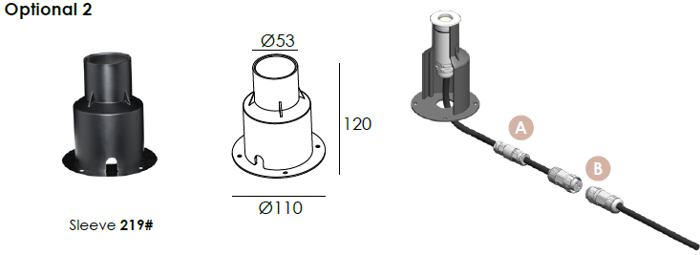
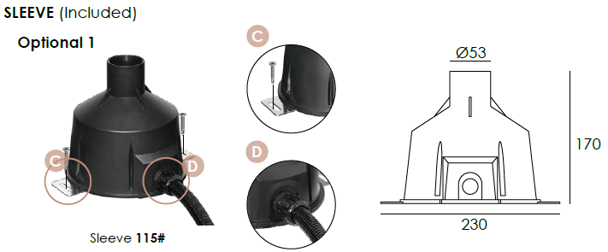

PHOTOMETRIC
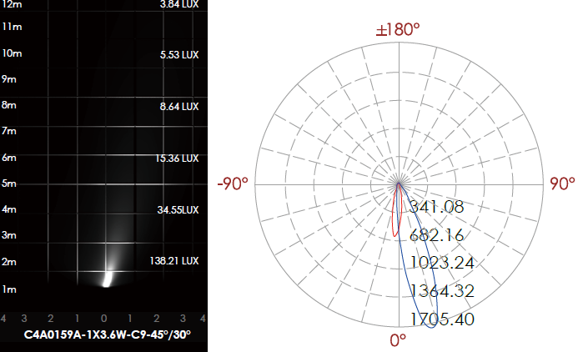

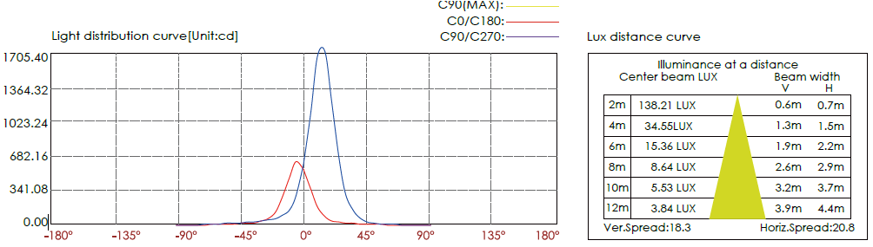

CERTIFICATES


