
Datasheet
No.: B4YBA0658F-DC 24- FB14B7-20°
Version: 2025-11-18-02
ITEM: B4YBA0658F | INPUT VOLTAGE(V)  DC 24 | LENS  FB14B7 | LENS DEGREE(°)θ1/2  20° |  | CCT  3000K
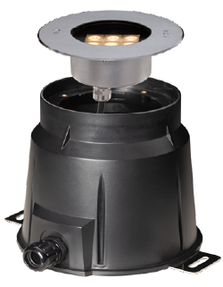  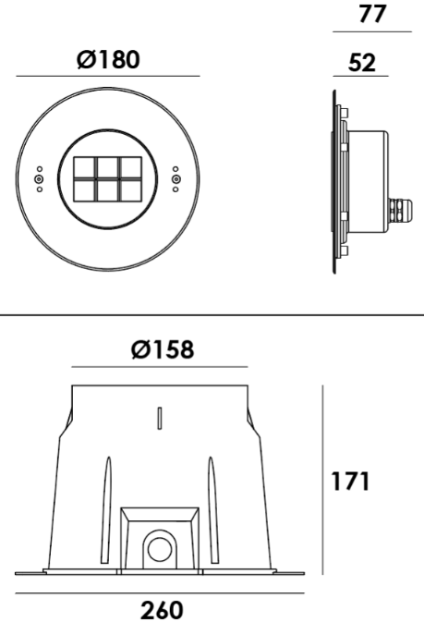 |  | LIGHT SOURCE |  | 6×3W
 |  | CONSUMPTION(W) |  | 24.5
 |  | OPERATING CURRENT(MA) |  | 1020
 |  | POWER FACTOR(PF) |  | 1
 |  | LUMINANCE(LM) |  | 1846
 |  | COLOR RENDERING INDEX |  | RA: 80
 |  | IK RATING |  | 08
 |  | IP RATING |  | 68
PRODUCT SPECIFICATIONS
FRONT COVER & HOUSING | Hard chromeplated molding shaped stainless steel SUS 316L#
LIGHT WINDOW | step Tempered glass. T=8mm
GLASS PRESSURE CAPACITY | 1926kgs
CABLE GLAND | IP68 PG-11 copper with nickel-coated
GASKET | Silicone gasket
LENS | All-in-one OPTICS lens,efficiency≥85%
LED TYPE | SMD
PCB | Excellent heat conductivity aluminum.coefficient of heatConductivity≥2.0w/mk
LED DRIVER | Constant Voltage Input,Constant Current Output
BUILT-IN OVERHEAT SENSOR SYSTEM | Automatic Shutdown at 75°C
POWER CABLE OPTIONAL | Outside of luminaire  H07RN-F 2×1.0mm2 with water-stopper, L=3m, 5m
OPERATING TEMPERATURE | -20˚C~40˚C
DIMMING SUPPORT | Triac PWM Available 1-10V Dali Customized
RECESSED SLEEEVE | 118# PC/ABS ALLOYS, with 304 stainless steel bottom plate

WATER PROOF SOLUTION
A. Water-Stopper(Included)
IP-68 water-stopper is added in the end of luminaires as standard assembly
which is also an important system for water resistance.

B. IP68 Jiffy quick plug/socket connector(Optional)
IP-68 connector is as an Optional assembly and ensures that water vapor
will not enter into luminaires directly.

C. Fixator: Easier mounting sleeve installment

D. IP68 cable gland: Prevents water from getting
into the cable tube.
※ Please prepare your own cable tube.
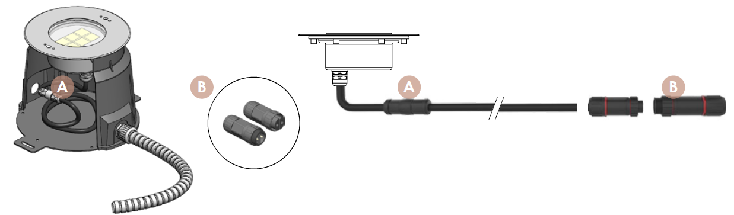
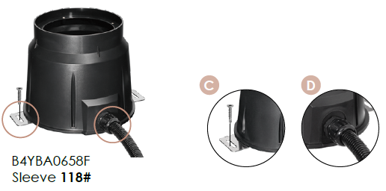
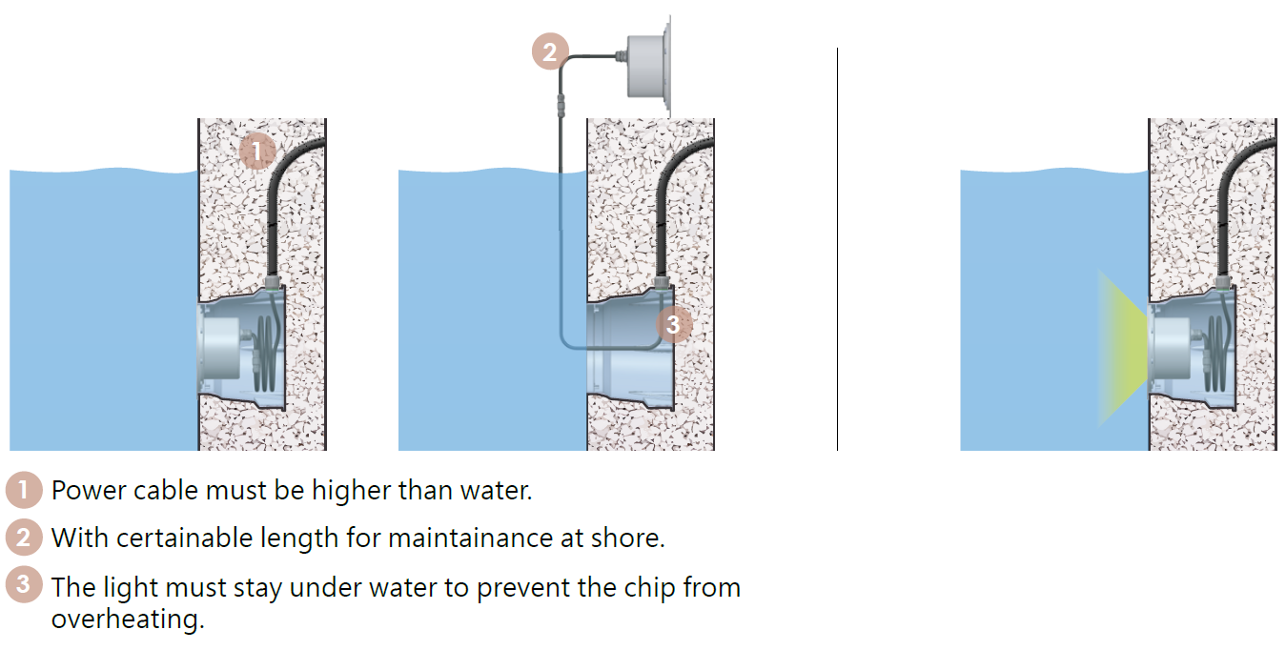

PHOTOMETRIC
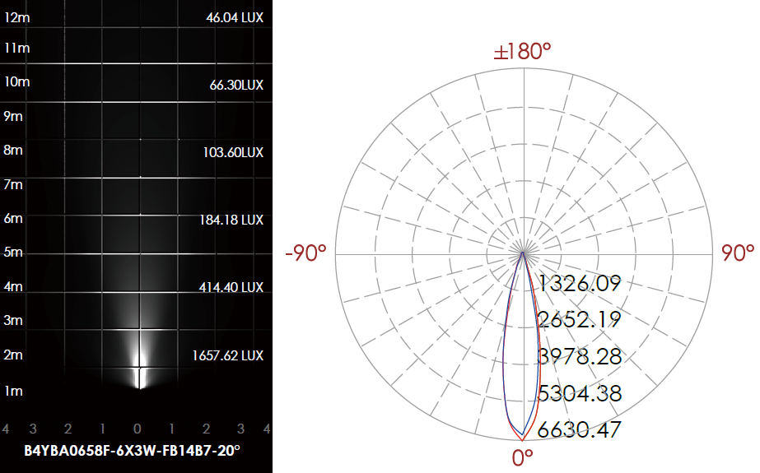

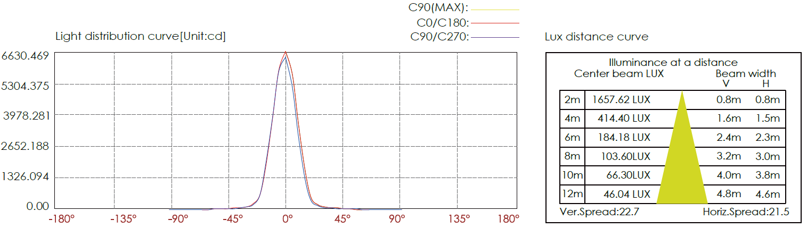

CERTIFICATES



