
Datasheet
No.: D1FL1014-DC 24
Version: 2025-11-17-02
ITEM: D1FL1014 | INPUT VOLTAGE(V)  DC 24 |  | LENS  N/A | LENS DEGREE(°)θ1/2  N/A |  | CCT  3000K
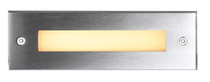  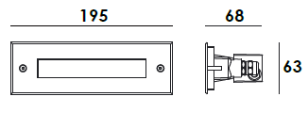 |  |  | LIGHT SOURCE |  | 10×0.2W
 |  |  | CONSUMPTION(W) |  | 2.7
 |  |  | OPERATING CURRENT(MA) |  | 114
 |  |  | POWER FACTOR(PF) |  | 1
 |  |  | LUMINANCE(LM) |  | CW=50 WW=42
 |  |  | COLOR RENDERING INDEX |  | RA: 80
 |  |  | IK RATING |  | 09
 |  |  | IP RATING |  | 65
PRODUCT SPECIFICATIONS
FRONT COVER | Stainless Steel 316L#
HOUSING | 12# Die-casting grey powder coated aluminum T=60-80μm.  Adhesion of ISO class 1/ASTM class 4B
LIGHT WINDOW | Tempered step glass.T=8mm, white print
LED TYPE | SDM
CABLE GLAND | IP68 PG-9 PA66
GASKET | Tooling shaped seal
RECESSED SLEEVE | PC/ABS ALLOYS 076#
LED DRIVER | Constant Voltage Input, Constant Current Output
OPERATING TEMPERATURE | -20˚ C~40˚ C
POWER CABLE | Outside of luminaire  H05RN-F 2×1.0mm², L=0.5m(12V/24V)
IP | IP65
DIMMING SUPPORT | Triac PWM Available 1-10V Dali Customized
RECESSED SLEEVE(Included) |  | DIAGRAM OF INSTRUCTION
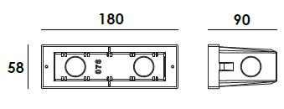  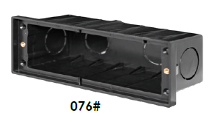 |  | 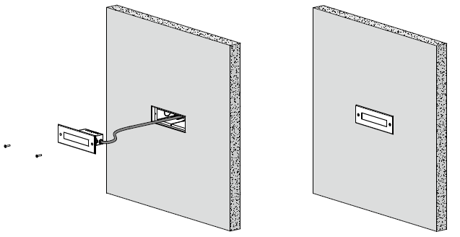

PAINTING COLOR
  Primary   |     Secondary    

PHOTOMETRIC
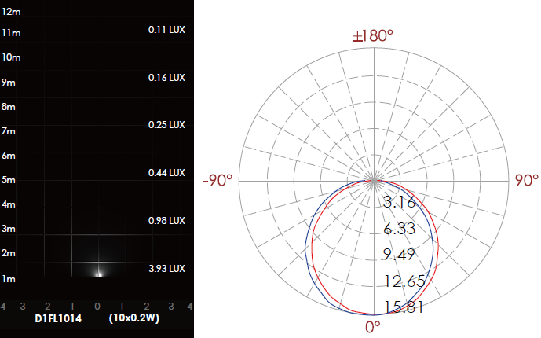

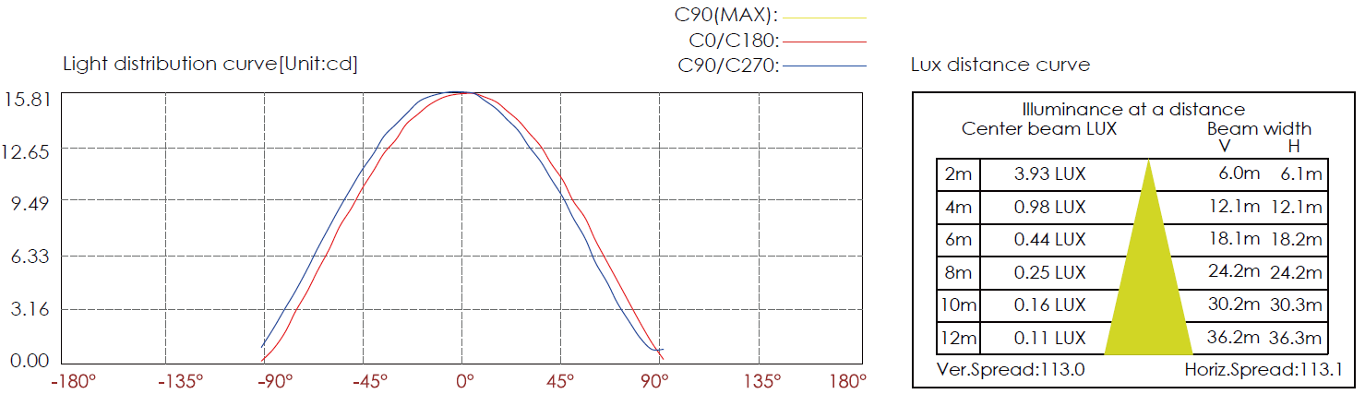

CERTIFICATES


