
Datasheet
No.: D1CY0934-240
Version: 2025-11-17-03
ITEM: D1CY0934 | INPUT VOLTAGE(V)  240 |  | LENS  N/A | LENS DEGREE(°)θ1/2  N/A |  | CCT  3000K
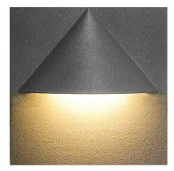  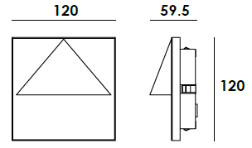 |  |  | LIGHT SOURCE |  | 9×0.5W
 |  |  | CONSUMPTION(W) |  | 6.3
 |  |  | OPERATING CURRENT(MA) |  | 46
 |  |  | POWER FACTOR(PF) |  | 0.509
 |  |  | LUMINANCE(LM) |  | 199
 |  |  | COLOR RENDERING INDEX |  | RA: 80
 |  |  | IK RATING |  | 07
 |  |  | IP RATING |  | 65
PRODUCT SPECIFICATIONS
HOUSING | 12# Die-casting RAL9005 powder coated aluminum.  T=60-80μm. Adhesion of ISO class 1/ASTM class 4B
LIGHT WINDOW | Tempered glass
CABLE GLAND | IP67 copper and nicked coated
GASKET | Waterproof silicone gasket
LED TYPE | SMD
DRIVER | Built in on/off driver
RECESSED SLEEVE | PC/ABS ALLOYS 150#
LED DRIVER | Constant Voltage Input,Constant Current Output
OPERATING TEMPERATURE | -20˚ C~40˚ C
POWER CABLE | Outside of luminaire (Without waterstopper)  H05RN-F 3×1.0mm², L=0.5m(120V/240V)
DIMMING SUPPORT | External DALI supported TRIAC ,0-10V,PWM via external driver on request
RECESSED SLEEVE(Included) |  | DIAGRAM OF INSTRUCTION
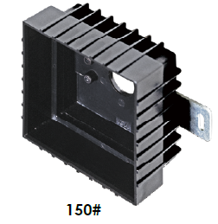  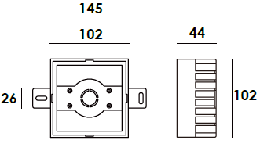 |  | 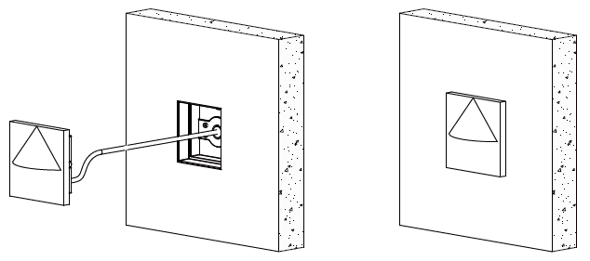

PAINTING COLOR
  Primary   |     Secondary    

PHOTOMETRIC
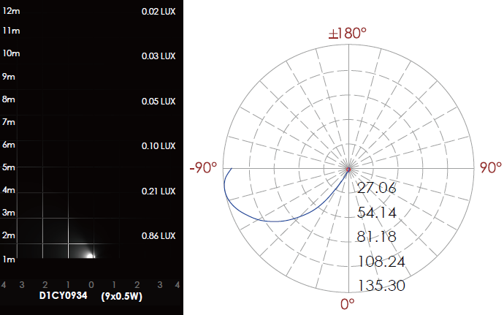

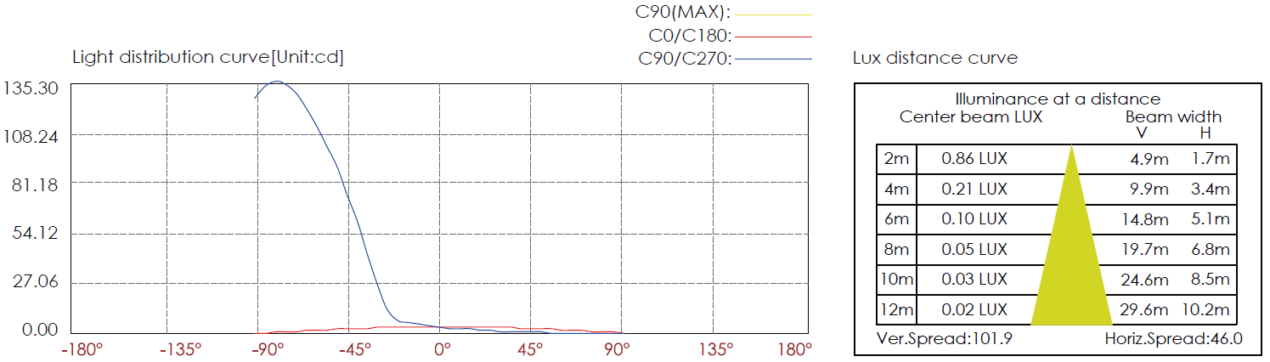

CERTIFICATES



