
Datasheet
No.: B2RQB1256P-DC 24-B15-15°
Version: 2025-11-10-02
ITEM: B2RQB1256P | INPUT VOLTAGE(V)  DC 24 | LENS  B15 | LENS DEGREE(°)θ1/2  15° |  | CCT  3000K
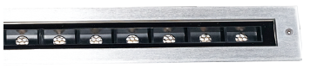  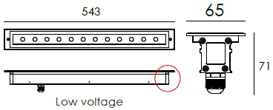 |  | LIGHT SOURCE |  | 12×1.2W
 |  | CONSUMPTION(W) |  | 19.2
 |  | OPERATING CURRENT(MA) |  | 800
 |  | POWER FACTOR(PF) |  | 1
 |  | LUMINANCE(LM) |  | 1515
 |  | COLOR RENDERING INDEX |  | RA: 80
 |  | IK RATING |  | 09
 |  | IP RATING |  | 67
PRODUCT SPECIFICATIONS
HOUSING | Extruded aluminum, powder coated
FRONT COVER | Hard chrome-plated stainess steel SUS 316L
LIGHT WINDOW | Tempered step glass. T=6mm
LENS | OPTICS lens.efficiency≥85%
CABLE GLAND | IP68 PG-9 PA66
GASKET | Glass and housing are silicone sealed
LED TYPE | SMD
OPERATING TEMPERATURE | -20˚ C~40˚ C
POWER CABLE | Outside of luminaire  12V/24V: H05RN-F 2×1.0mm², L=0.5m
MOUNTING SLEEVE | Powder Coated Aluminum
DIMMING SUPPORT | Triac PWM Available 1-10V Dali Customized
WATER PROOF SOLUTION
A. Water-Stopper(Included)
IP-67 water-stopper is added in the end of luminaires as standard
Assembly which is also an important system for water resistance.
B. IP67 Jiffy quick plug/socket connector(Optional)
IP-67 connector is as an Optional assembly and ensures that water vapor
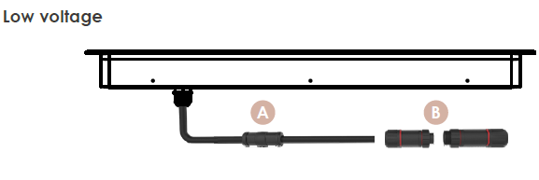
will not enter into luminaires directly.

ACCESSORIES(Optional)
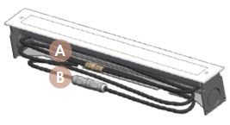
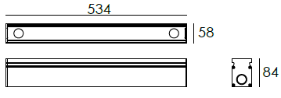
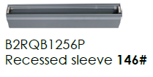
SLEEVE

PHOTOMETRIC
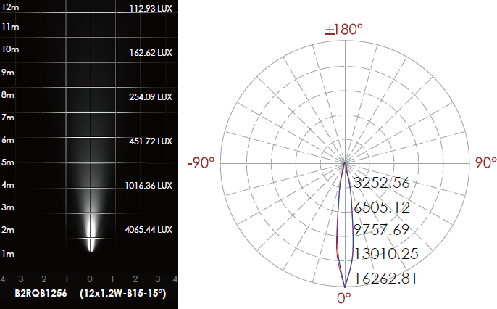

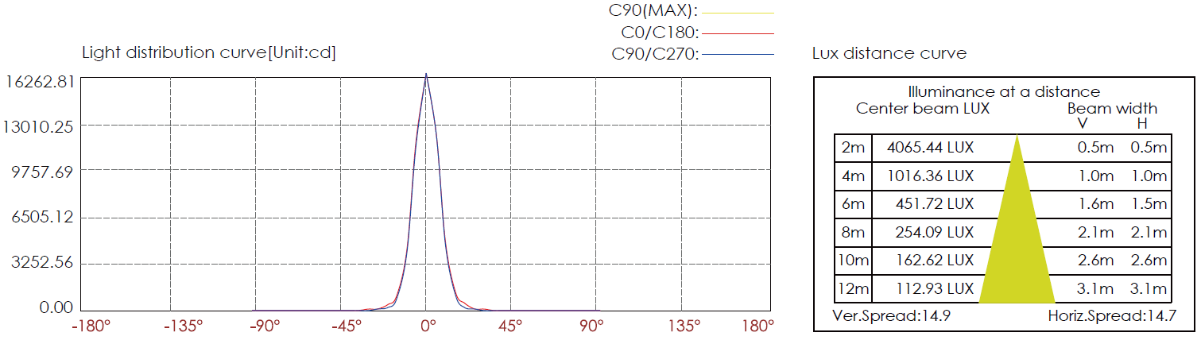

CERTIFICATES


