
Datasheet
No.: B7GR1256 (TWO SIDE)-240-B116-40°
Version: 2025-10-14-03
ITEM: B7GR1256 (TWO SIDE) | INPUT VOLTAGE(V)  240 | LENS  B116 | LENS DEGREE(°)θ1/2  40° |  | CCT  3000K
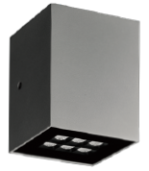  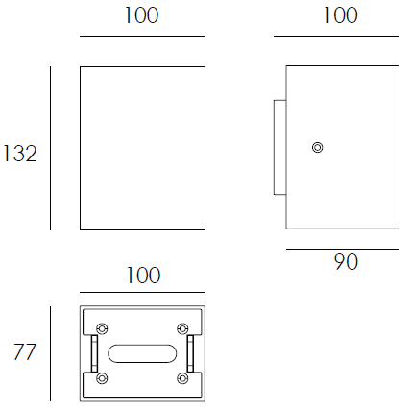 |  | LIGHT SOURCE |  | 12×1W
 |  | CONSUMPTION(W) |  | 13.6
 |  | OPERATING CURRENT(MA) |  | 60
 |  | POWER FACTOR(PF) |  | 0.889
 |  | LUMINANCE(LM) |  | 600×2
 |  | COLOR RENDERING INDEX |  | RA: 80
 |  | IK RATING |  | 07
 |  | IP RATING |  | 65
PRODUCT SPECIFICATIONS
HOUSING | 12# Die-casting aluminum finishing or powder painting T=60-80µm.  Adhesion of ISO class 1/ASTM class 4B
LIGHT WINDOW | Temperetd glass T=3mm
LED TYPE | SMD
GASKET | Tooling shaped seal
DRIVER | Built-in driver
OPERATING TEMPERATURE | -20°C-40°C
POWER CABLE | Outside of luminaire  120V/240V: H05RN-F 3×1.0mm², L=0.3m
DIMMING SUPPORT | Triac PWM Available 1-10V Dali Customized
DIAGRAM OF INSTRUCTION
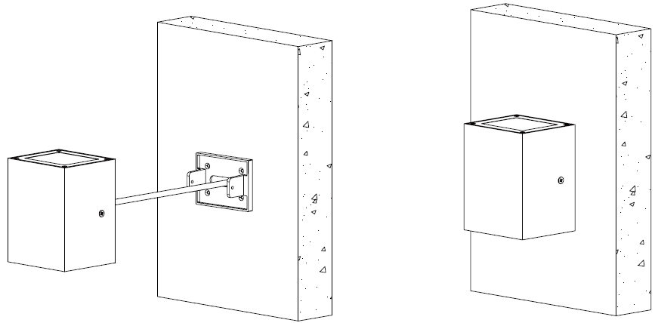
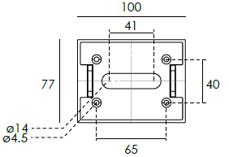

PAINTING COLOR
  Primary   |       Secondary      

PHOTOMETRIC
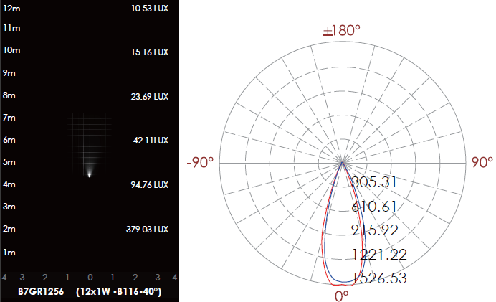

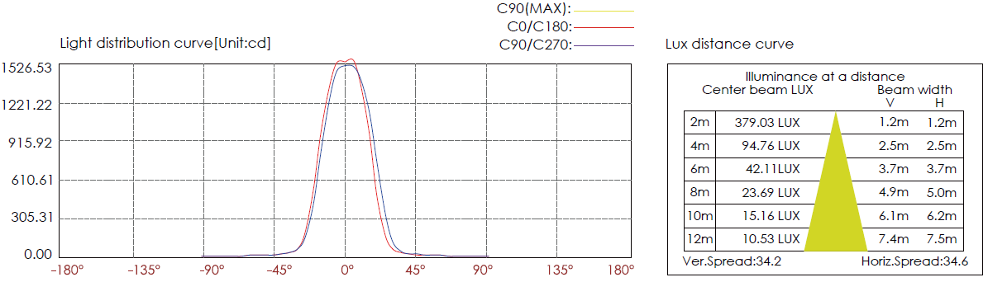

CERTIFICATES


