
Datasheet
No.: B8VH0126-240-B71-60°
Version: 2025-09-03-01
ITEM: B8VH0126 | INPUT VOLTAGE(V)  240 | LENS  B71 | LENS DEGREE(°)θ1/2  60° |  | CCT  3000K
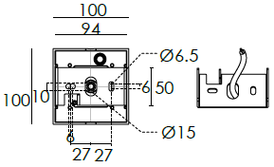  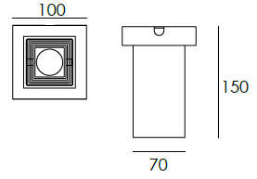  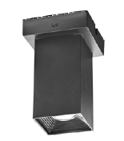 |  | LIGHT SOURCE |  | 1×6W
 |  | CONSUMPTION(W) |  | 8
 |  | OPERATING CURRENT(MA) |  | 36
 |  | POWER FACTOR(PF) |  | 0.747
 |  | LUMINANCE(LM) |  | 699
 |  | COLOR RENDERING INDEX |  | RA: 80
 |  | IK RATING |  | 08
 |  | IP RATING |  | 65
PRODUCT SPECIFICATIONS
HOUSING MATERIAL | Extruded aluminum alloy #6063
PAINTING | Powder coating, T= 60~80 μm.  Adhesion of ISO class 1/ASTM class 4B
REFLECTOR | OPTICS reflector. efficiency≥85%
LED TYPE | COB
POWER CABLE | Outside of luminaire  H05RN-F 3×1.0mm², L=0.3m(120V/240V)
OPERATING TEMPERATURE | -20˚ C~40˚ C
ACCESSORIES(Optional)
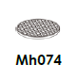
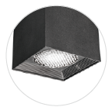

FEATURES
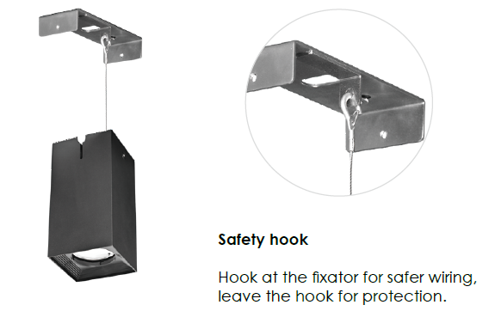

PAINTING COLOR
  Regular   |       Secondary      

PHOTOMETRIC
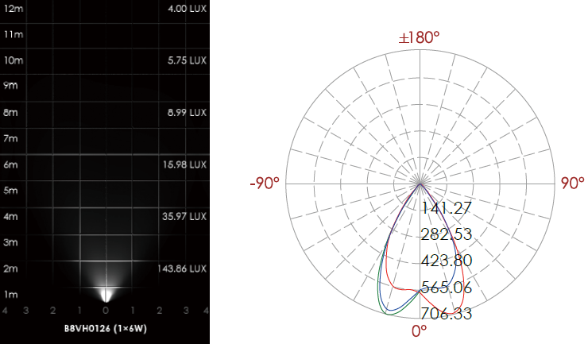

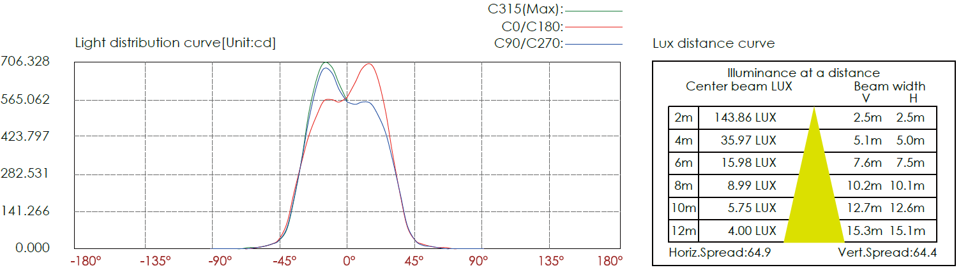

CERTIFICATES


