
Datasheet
No.: R7BC0129-120 240-R3-25°
Version: 2025-09-03-01
ITEM: R7BC0129 | INPUT VOLTAGE(V)  120 240 | REFLECTOR  R3 | LENS DEGREE(°)θ1/2  25° |  | CCT  3000K
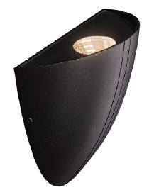  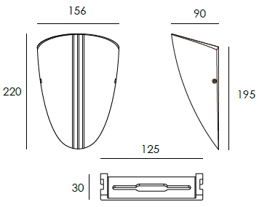 |  | LIGHT SOURCE |  | 1×12W
 |  | CONSUMPTION(W) |  | 120=14 240=14.1
 |  | OPERATING CURRENT(MA) |  | 120=112 240=64
 |  | POWER FACTOR(PF) |  | 0.932
 |  | LUMINANCE(LM) |  | CW=1508 WW=1432
 |  | COLOR RENDERING INDEX |  | RA: 80
 |  | IK RATING |  | 05
 |  | IP RATING |  | 65
PRODUCT SPECIFICATIONS
HOUSING | 12# Die-casting aluminum finishing or powder painting T=60-80μm.  Adhesion of ISO class 1/ASTM class 4B
LIGHT WINDOW | Tempered glass. T=3.5mm
LED DRIVER | Constant voltage input, constant current output
LED TYPE | COB
OPERATING TEMPERATURE | -20˚ C-40˚ C
POWER CABLE | Outside of luminaire  120V/240V: H05RN-F 3×1.0mm², L=0.3m
DIAGRAM OF INSTRUCTION
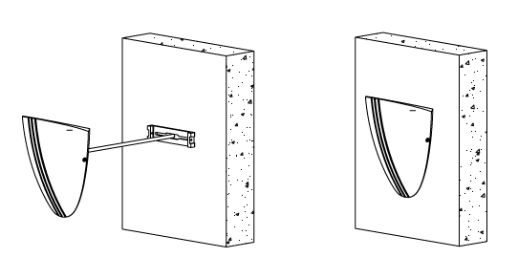
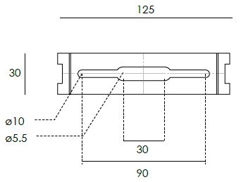

PAINTING COLOR
  Regular   |       Secondary      

PHOTOMETRIC
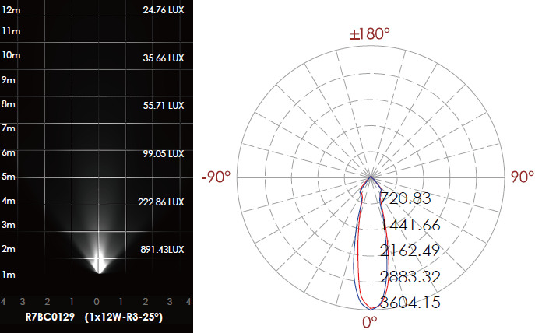

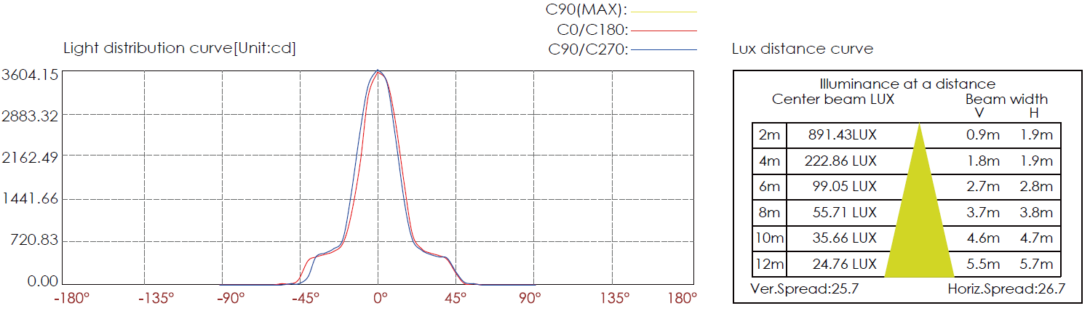

CERTIFICATES


