
Datasheet
No.: B7FMH0958-120 240-FB11B5-9°
Version: 2025-09-03-01
ITEM: B7FMH0958 | INPUT VOLTAGE(V)  120 240 | LENS  FB11B5 | LENS DEGREE(°)θ1/2  9° |  | CCT  3000K
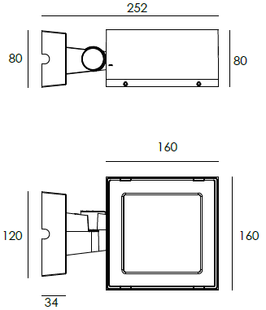  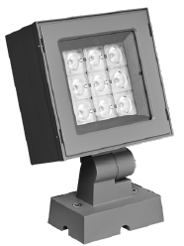  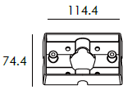 |  | LIGHT SOURCE |  | 9×3W
 |  | CONSUMPTION(W) |  | 120V=29.6 240V=30
 |  | OPERATING CURRENT(MA) |  | 120V=245 240V=133
 |  | POWER FACTOR(PF) |  | 1
 |  | LUMINANCE(LM) |  | 2632
 |  | COLOR RENDERING INDEX |  | RA: 80
 |  | IK RATING |  | 06
 |  | IP RATING |  | 65
PRODUCT SPECIFICATIONS
HOUSING | 12# Die-casting aluminum finishing or powder painting T=60-80μm.  Adhesion of ISO class 1/ASTM class 4B
LIGHT WINDOW | Tempered glass.T=3mm
CABLE GLAND | IP68 PG-9 PA66
GASKET | Tooling shaped seal
LED TYPE | SMD
LED DRIVER | Constant Voltage Input,Constant Current Output
POWER CABLE | Outside of luminaire  120V/240V: H05RN-F 3×1.0mm², L=0.3m
DIMMING SUPPORT | Triac PWM Available  1-10V Dali Customized
DIAGRAM OF INSTRUCTION
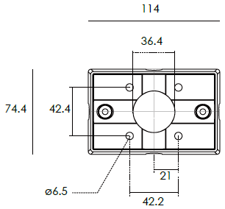
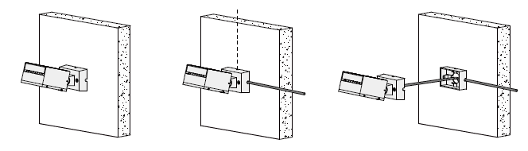

DIAGRAM OF INSTRUCTION
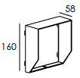  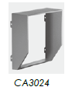  BEVEL CUT HOOD | 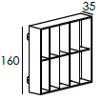  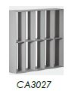  ANTI GLARE LOUVER

PAINTING COLOR
  Regular   |       Secondary      

PHOTOMETRIC
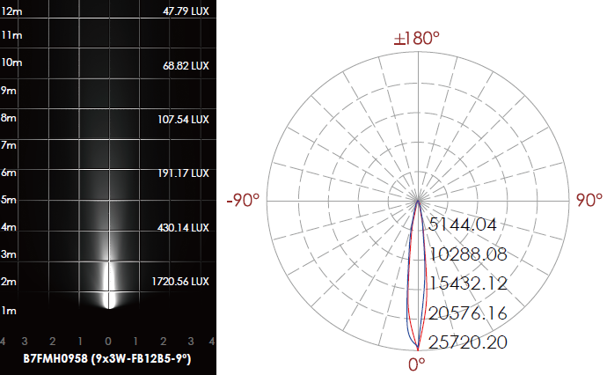

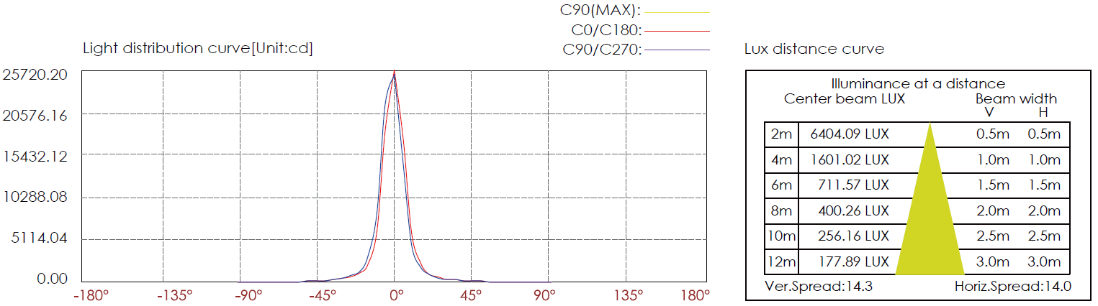

CERTIFICATES


