
Datasheet
No.: B7DH0224-240-B54-24°
Version: 2025-09-03-01
ITEM: B7DH0224 | INPUT VOLTAGE(V)  240 | LENS  B54 | LENS DEGREE(°)θ1/2  24° |  | CCT  3000K
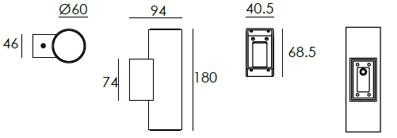  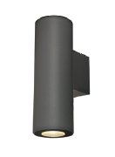 |  | LIGHT SOURCE |  | 2×4.5W
 |  | CONSUMPTION(W) |  | 10.7
 |  | OPERATING CURRENT(MA) |  | 49
 |  | POWER FACTOR(PF) |  | 0.916
 |  | LUMINANCE(LM) |  | 282×2
 |  | COLOR RENDERING INDEX |  | RA: 80
 |  | IK RATING |  | 05
 |  | IP RATING |  | 65
PRODUCT SPECIFICATIONS
HOUSING MATERIAL | Extruded aluminum alloy #6063
PAINTING | Powder coating ,T= 60-80 μm.  Adhesion of ISOclass 1/ASTM class 4B
REFLECTOR | OPTICS reflector. efficiency≥85%
LED TYPE | COB
OPERATING TEMPERATURE | -20°C- 40°C
POWER CABLE | Outside of luminaire  120V/240V: H05RN-F 3×1.0mm², L=0.3m
DIAGRAM OF INSTRUCTION
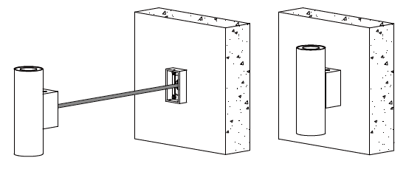
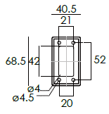

PAINTING COLOR
  Regular   |       Secondary      

PHOTOMETRIC
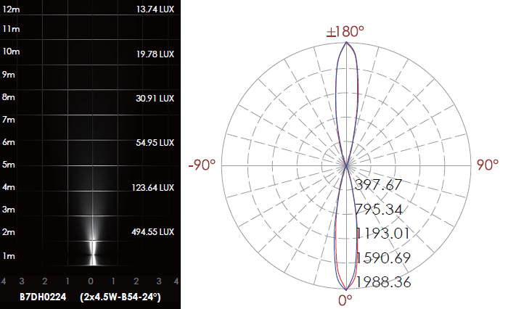

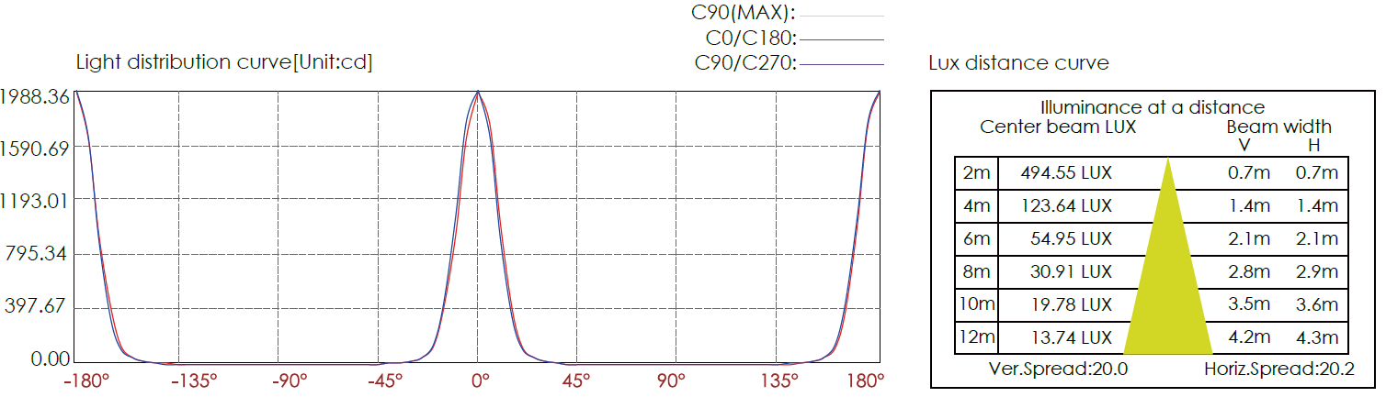

CERTIFICATES



