
Datasheet
No.: 2ED7GBE1656 (TWO SIDE)-240-89°×65°
Version: 2025-09-03-01
ITEM: 2ED7GBE1656 (TWO SIDE) | INPUT VOLTAGE(V)  240 | LENS  N/A | LENS DEGREE(°)θ1/2  89°×65° |  | CCT  3000K
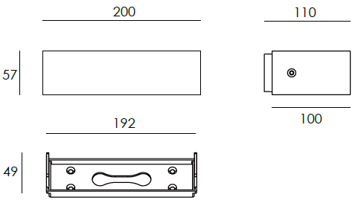  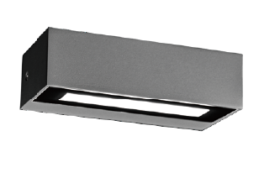 |  | LIGHT SOURCE |  | 16×1W
 |  | CONSUMPTION(W) |  | 20
 |  | OPERATING CURRENT(MA) |  | 87
 |  | POWER FACTOR(PF) |  | 0.926
 |  | LUMINANCE(LM) |  | 474×2
 |  | COLOR RENDERING INDEX |  | RA: 80
 |  | IK RATING |  | 03
 |  | IP RATING |  | 65
PRODUCT SPECIFICATIONS
HOUSING | 12# Die-casting aluminum finishing or powder painting T=60-80µm.  Adhesion of ISO class 1/ASTM class 4B
LIGHT WINDOW | Temperetd forsted glass T=3mm
LED TYPE | SMD
GASKET | Tooling shaped seal
DRIVER | Built-in driver
OPERATING TEMPERATURE | -20°C-40°C
POWER CABLE | Outside of luminaire  120V/240V: H05RN-F 3×1.0mm², L=0.3m
DIMMING SUPPORT | Triac PWM Available 1-10V Dali Customized
DIAGRAM OF INSTRUCTION
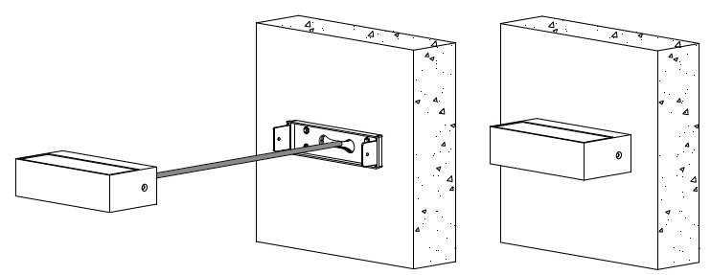
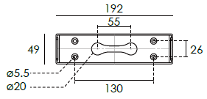

PAINTING COLOR
  Regular   |       Secondary      

PHOTOMETRIC
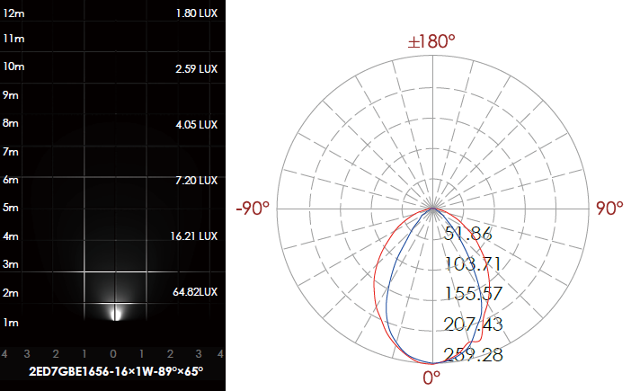

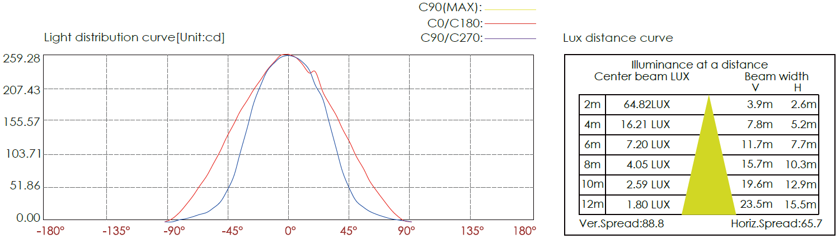

CERTIFICATES


