
Datasheet
No.: R7CJM0171T-DC 24-R19-22°
Version: 2025-09-03-01
ITEM: R7CJM0171T | INPUT VOLTAGE(V)  DC 24 | REFLECTOR  R19 |  | LENS DEGREE(°)θ1/2  22° |  | CCT  3000K
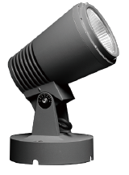  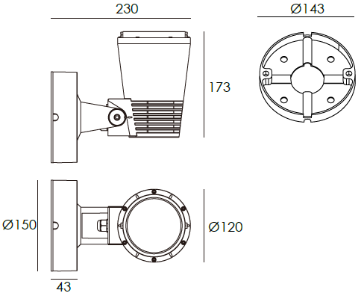 |  |  | LIGHT SOURCE |  | 1×20W
 |  |  | CONSUMPTION(W) |  | 23
 |  |  | OPERATING CURRENT(MA) |  | 960
 |  |  | POWER FACTOR(PF) |  | 1
 |  |  | LUMINANCE(LM) |  | CW=2596 WW=2409
 |  |  | COLOR RENDERING INDEX |  | RA: 80
 |  |  | IK RATING |  | 06
 |  |  | IP RATING |  | 65
PRODUCT SPECIFICATIONS
HOUSING | 12# Die-casting aluminum finishing or powder painting T=60-80μm.  Adhesion of ISO class 1/ASTM class 4B
LIGHT WINDOW | Tempered glass.T=3mm
CABLE GLAND | IP68 PG-9 PA66
GASKET | Tooling shaped seal
LED TYPE | COB
LED DRIVER | Constant Voltage Input,Constant Current Output
POWER CABLE | Outside of luminaire 12V/24V: H05RN-F 2×1.0mm², L=0.3m
DIMMING SUPPORT | Triac PWM Available 1-10V Dali Customized
DIAGRAM OF INSTRUCTION
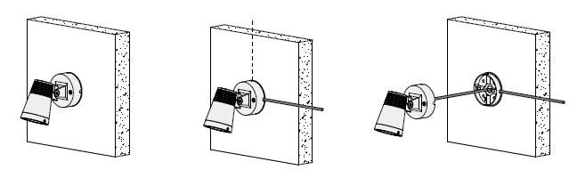
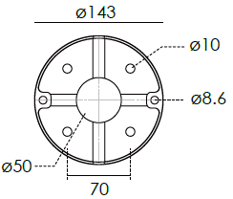

ACCESSORIES(Optional)
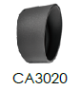  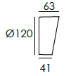  BEVEL CUT HOOD | 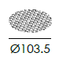  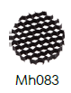  HONEYCOMB LOUVER

PAINTING COLOR
  Regular   |       Secondary      

PHOTOMETRIC
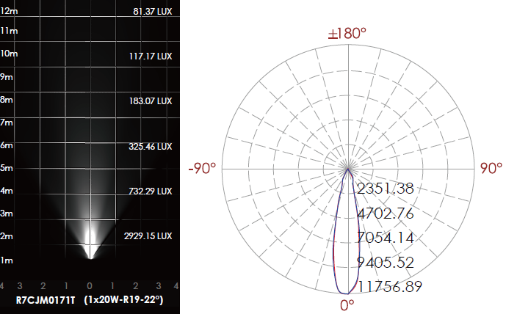

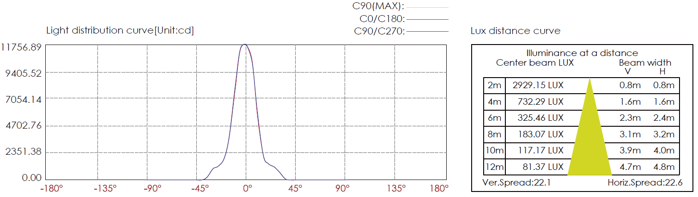

CERTIFICATES





