
Datasheet
No.: D7BJ0125-DC 24
Version: 2025-09-03-01
ITEM: D7BJ0125 | INPUT VOLTAGE(V)  DC 24 | LENS  N/A | LENS DEGREE(°)θ1/2  N/A |  | CCT  3000K
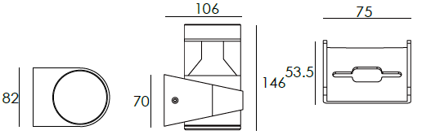  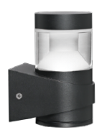 |  | LIGHT SOURCE |  | 1×4.5W
 |  | CONSUMPTION(W) |  | 5.5
 |  | OPERATING CURRENT(MA) |  | 230
 |  | POWER FACTOR(PF) |  | 1
 |  | LUMINANCE(LM) |  | 447
 |  | COLOR RENDERING INDEX |  | RA: 80
 |  | IK RATING |  | 08
 |  | IP RATING |  | 65
PRODUCT SPECIFICATIONS
HOUSING | 12# Die-casting aluminum finishing or powder painting T=60-80μm.  Adhesion of ISO class 1/ASTM class 4B
LIGHT WINDOW | PMMA Ø=76mm
LED DRIVER | Constant Voltage Input,Constant Current Output
LED TYPE | COB
OPERATING TEMPERATURE | -20˚ C-40˚ C
POWER CABLE | Outside of luminaire  12V/24V: H05RN-F 2×1.0mm², L=0.3m
DIAGRAM OF INSTRUCTION
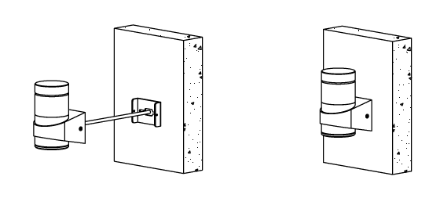
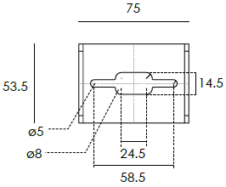

PAINTING COLOR
  Regular   |       Secondary      

PHOTOMETRIC
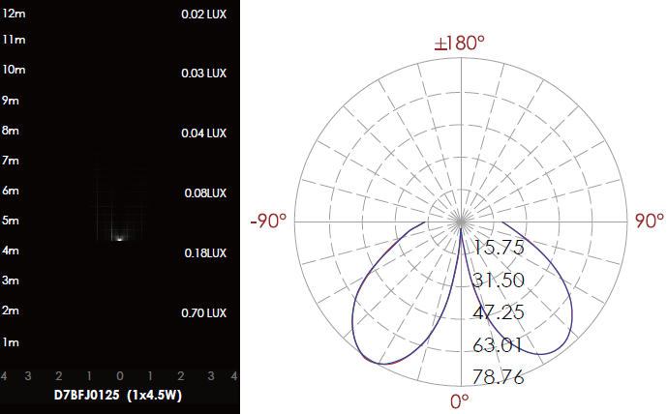

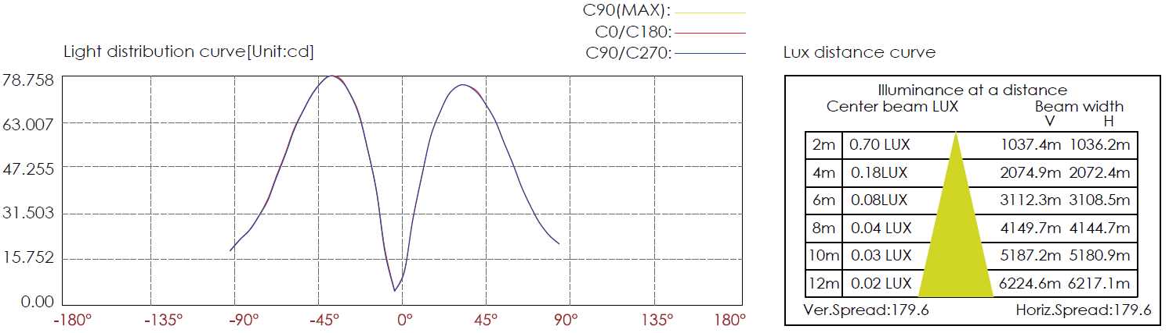

CERTIFICATES




