
Datasheet
No.: B7AEX0269-DC 24-B67-38°
Version: 2025-09-02-01
ITEM: B7AEX0269 | INPUT VOLTAGE(V)  DC 24 | LENS  B67 |  | LENS DEGREE(°)θ1/2  38° |  | CCT  3000K
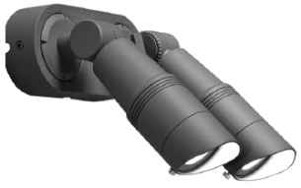  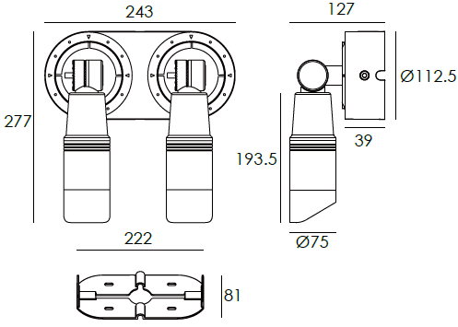 |  |  | LIGHT SOURCE |  | 2×14W
 |  |  | CONSUMPTION(W) |  | 30.6
 |  |  | OPERATING CURRENT(MA) |  | 1278
 |  |  | POWER FACTOR(PF) |  | 1
 |  |  | LUMINANCE(LM) |  | 1705×2
 |  |  | COLOR RENDERING INDEX |  | RA: 80
 |  |  | IK RATING |  | 05
 |  |  | IP RATING |  | 65
PRODUCT SPECIFICATIONS
FRONT COVER&HOUSING | 12# Die-casting aluminum finishing or powder painting T=60-80μm.  Adhesion of ISO class 1/ASTM class 4B
LENS | OPTICS lens, efficiency≥ 85%
LED TYPE | COB
LIGHT WINDOW | Tempered glass. T=3mm
CABLE GLAND | Nickel coated copper
GASKET | Tooling shaped seal
PCB | Excellent heat conductivity aluminum, coefficient of heat Conductivity≥ 2.0w/mk
LED DRIVER | Constant voltage input, constant current output
OPERATING TEMPERATURE | -20˚ C~40˚ C
POWER CABLE | Outside of luminaire  12V/24V: H05RN-F 2×1.0mm², L=0.4m
DIMMING SUPPORT | Triac PWM Available 1-10V Dali Customized
DIAGRAM OF INSTRUCTION
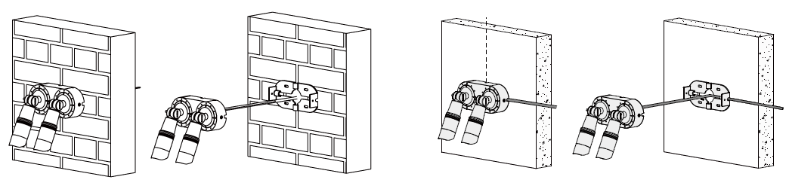
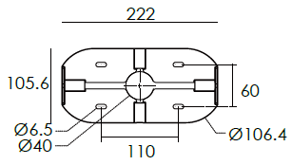

PAINTING COLOR
  Regular   |       Secondary      

PHOTOMETRIC
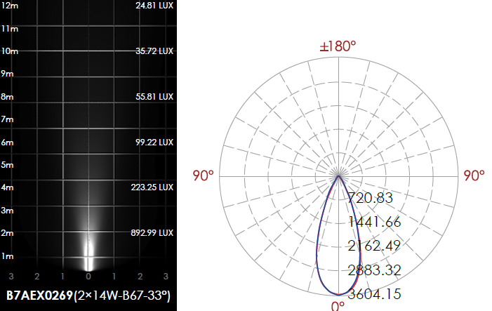

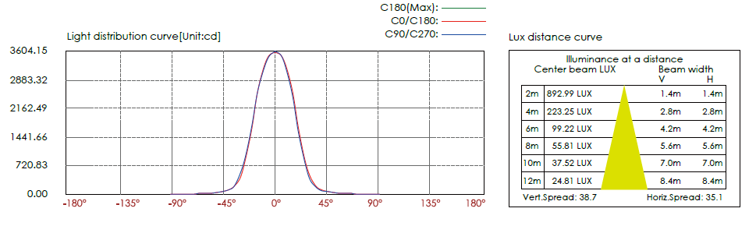

CERTIFICATES




