
Datasheet
No.: 2ED7EBE3256 (TWO SIDE)-DC 24-92°×88°
Version: 2025-09-02-01
ITEM: 2ED7EBE3256 (TWO SIDE) | INPUT VOLTAGE(V)  DC 24 | LENS  N/A |  | LENS DEGREE(°)θ1/2  92°×88° |  | CCT  3000K
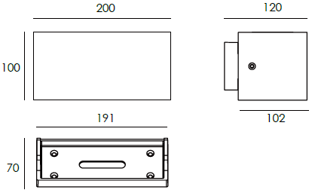  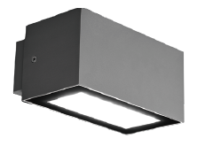 |  |  | LIGHT SOURCE |  | 32×1W
 |  |  | CONSUMPTION(W) |  | 41
 |  |  | OPERATING CURRENT(MA) |  | 1708
 |  |  | POWER FACTOR(PF) |  | 1
 |  |  | LUMINANCE(LM) |  | 1287×2
 |  |  | COLOR RENDERING INDEX |  | RA: 80
 |  |  | IK RATING |  | 02
 |  |  | IP RATING |  | 65
PRODUCT SPECIFICATIONS
HOUSING | 12# Die-casting aluminum finishing or powder painting T=60-80µm.  Adhesion of ISO class 1/ASTM class 4B
LIGHT WINDOW | Temperetd forsted glass T=3mm
LED TYPE | SMD
GASKET | Tooling shaped seal
DRIVER | Built-in driver
OPERATING TEMPERATURE | -20°C-40°C
POWER CABLE | Outside of luminaire  12V/24V: H05RN-F 2×1.0mm², L=0.3m
DIMMING SUPPORT | Triac PWM Available 1-10V Dali Customized
DIAGRAM OF INSTRUCTION
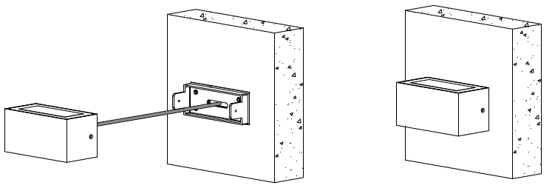
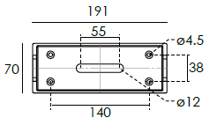

PAINTING COLOR
  Regular   |       Secondary      

PHOTOMETRIC
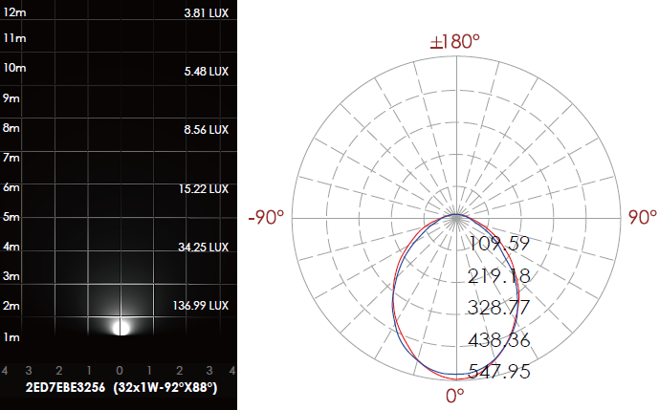

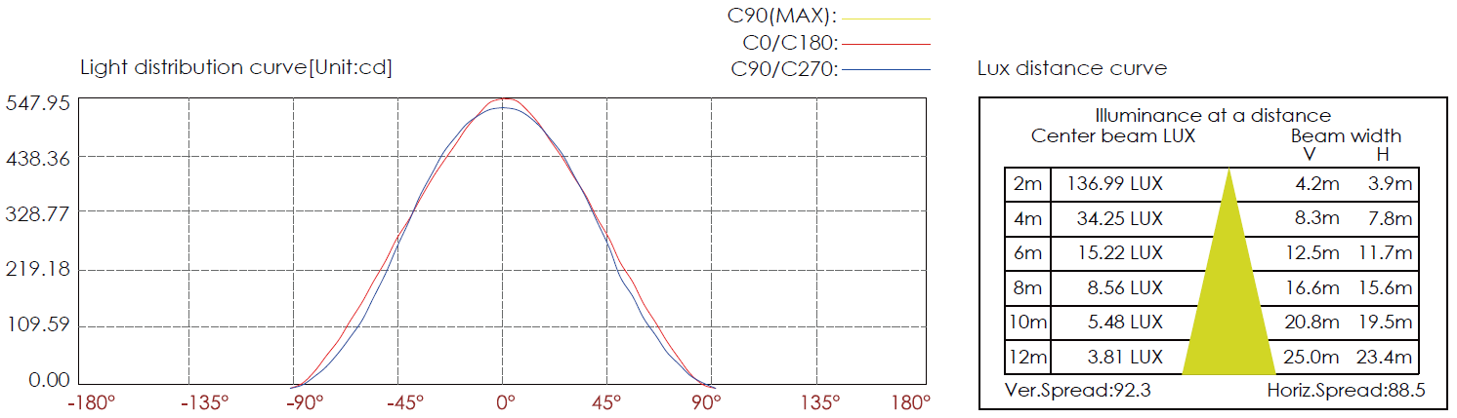

CERTIFICATES


