
Datasheet
No.: B3BG0127-DC 24-B55-24°
Version: 2025-09-02-01
ITEM: B3BG0127 | INPUT VOLTAGE(V)  DC 24 | LENS  B55 | LENS DEGREE(°)θ1/2  24° |  | CCT  3000K
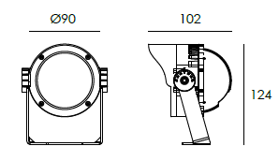  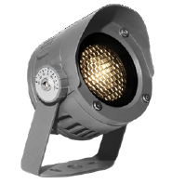 |  | LIGHT SOURCE |  | 1×8W
 |  | CONSUMPTION(W) |  | 8.9
 |  | OPERATING CURRENT(MA) |  | 374
 |  | POWER FACTOR(PF) |  | 1
 |  | LUMINANCE(LM) |  | 500
 |  | COLOR RENDERING INDEX |  | RA: 80
 |  | IK RATING |  | 07
 |  | IP RATING |  | 66
PRODUCT SPECIFICATIONS
HOUSING | 12# Die-casting aluminum finishing or powder painting T=60-80μm.  Adhesion of ISO class 1/ASTM class 4B
LENS | All-in-one OPTICS lens, efficiency≥85%
LIGHT WINDOW | Tempered glass.T=4mm
LED TYPE | COB
CABLE GLAND | IP68 PG-9 PA66
GASKET | Tooling shaped seal
BRACKET | Powder coated aluminum
POWER CABLE | Outside of luminaire 12V/24V: H05RN-F 2×1.0mm², L=2.0m
WATER PROOF SOLUTION
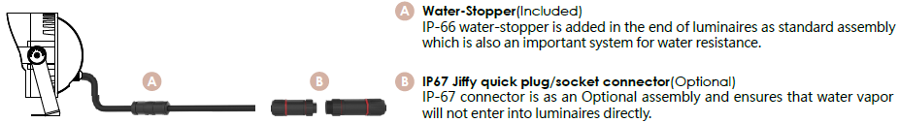

ACCESSORIES(Optional)
SPIKE  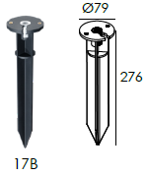  PC/ABS alloys | 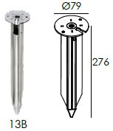  STAINLESS STEEL | ROUND SURFACE  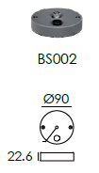  MOUNTING BASE

PAINTING COLOR
  Regular   |       Secondary      

PHOTOMETRIC
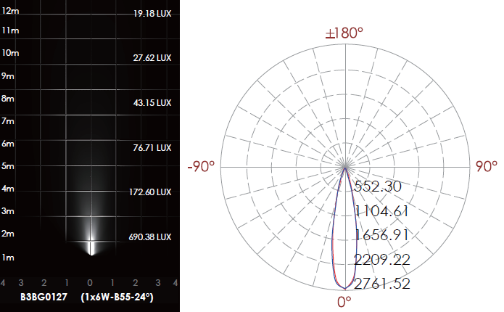

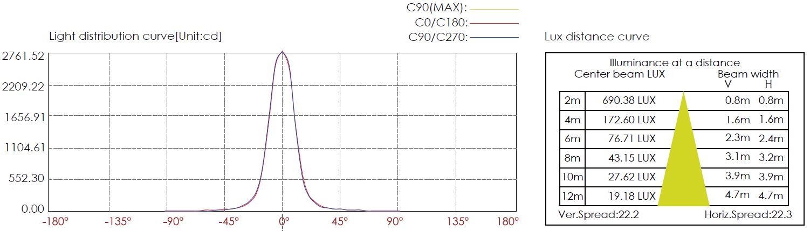

CERTIFICATES




