
Datasheet
No.: B3TMS0158-120 240-B33-20°
Version: 2025-09-02-01
ITEM: B3TMS0158 | INPUT VOLTAGE(V)  120 240 | LENS  B33 | LENS DEGREE(°)θ1/2  20° |  | CCT  3000K
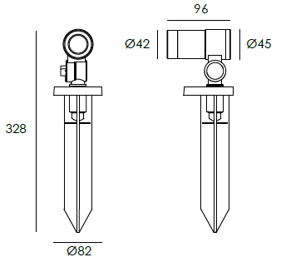  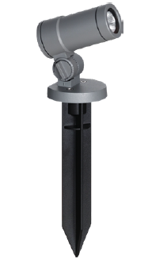 |  | LIGHT SOURCE |  | 1×3W
 |  | CONSUMPTION(W) |  | 120=5.3 240=5.4
 |  | OPERATING CURRENT(MA) |  | 120=45 240=26
 |  | POWER FACTOR(PF) |  | 0.801
 |  | LUMINANCE(LM) |  | CW=305 WW=274
 |  | COLOR RENDERING INDEX |  | RA: 80
 |  | IK RATING |  | 06
 |  | IP RATING |  | 66
PRODUCT SPECIFICATIONS
HOUSING | 12# Die-casting aluminum finishing or powder painting T=60-80μm.  Adhesion of ISO class 1/ASTM class 4B
LIGHT WINDOW | Tempered glass.T=4mm
GASKET | Tooling shaped seal
LED TYPE | COB
LED DRIVER | Constant Voltage Input, Constant Current Output
LENS/REFLECTOR | OPTICS lens,effciency≥85%
OPERATING TEMPERATURE | -20℃ ~40℃
POWER CABLE | Outside of luminaire  120V/240V: H05RN-F 3×1.0mm², L=2.0m
WATER PROOF SOLUTION
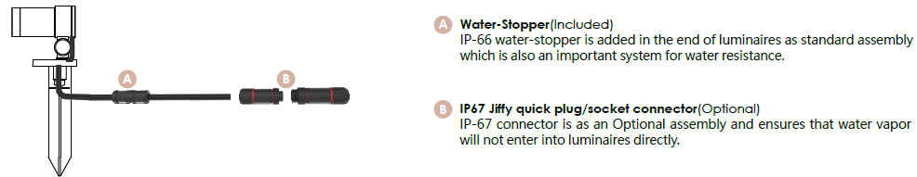

ACCESSORIES(Optional)
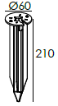  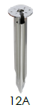  SPIKE  STAINLESS STEEL | 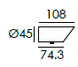  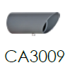  BEVEL CUT HOOD
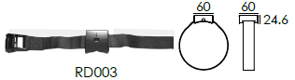  TREE POLE STRAP | 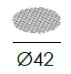  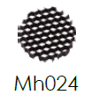  HONEYCOMB LOUVER

PAINTING COLOR
  Regular   |       Secondary      

PHOTOMETRIC
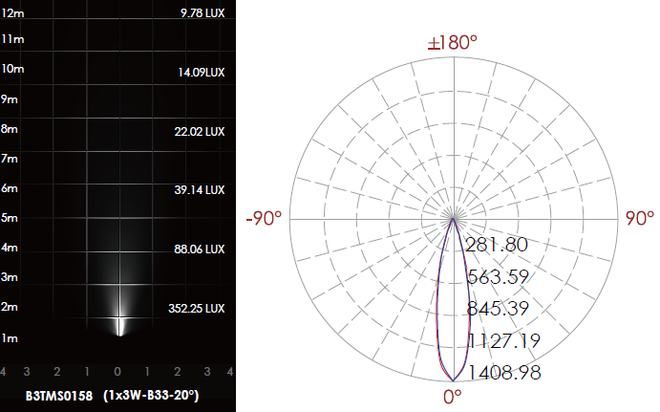

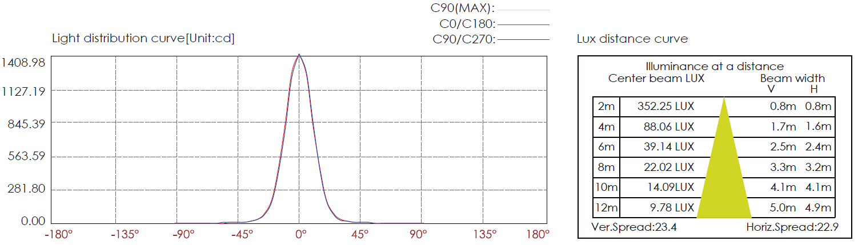

CERTIFICATES


