
Datasheet
No.: B3FKA0559-120 240-FB12B5-45°
Version: 2025-09-02-01
ITEM: B3FKA0559 | INPUT VOLTAGE(V)  120 240 | LENS  FB12B5 | LENS DEGREE(°)θ1/2  45° |  | CCT  3000K
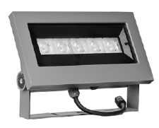  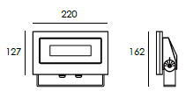 |  | LIGHT SOURCE |  | 5×3.5W
 |  | CONSUMPTION(W) |  | 120=21.7 240=21.7
 |  | OPERATING CURRENT(MA) |  | 120=181 240=94
 |  | POWER FACTOR(PF) |  | 0.929
 |  | LUMINANCE(LM) |  | 1324
 |  | COLOR RENDERING INDEX |  | RA: 80
 |  | IK RATING |  | 06
 |  | IP RATING |  | 66
PRODUCT SPECIFICATIONS
HOUSING | 12# Die-casting aluminum finishing or powder painting T=60-80μm.  Adhesion of ISO class 1/ASTM class 4B
LIGHT WINDOW | Tempered glass.T=3mm
LED TYPE | SMD
LED DRIVER | Constant Voltage Input, Constant Current Output
CABLE GLAND | IP68 PG-9 PA66
GASKET | Tooling shaped seal
POWER CABLE | Outside of luminaire  120V/240V: H05RN-F 3×1.0mm², L=2.0m
DIMMING SUPPORT | Triac PWM Available 1-10V Dali Customized
WATER PROOF SOLUTION
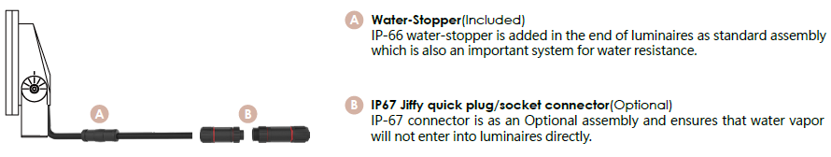

PAINTING COLOR
  Regular   |       Secondary      

PHOTOMETRIC
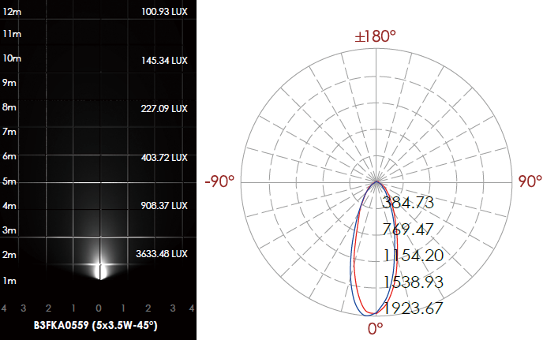

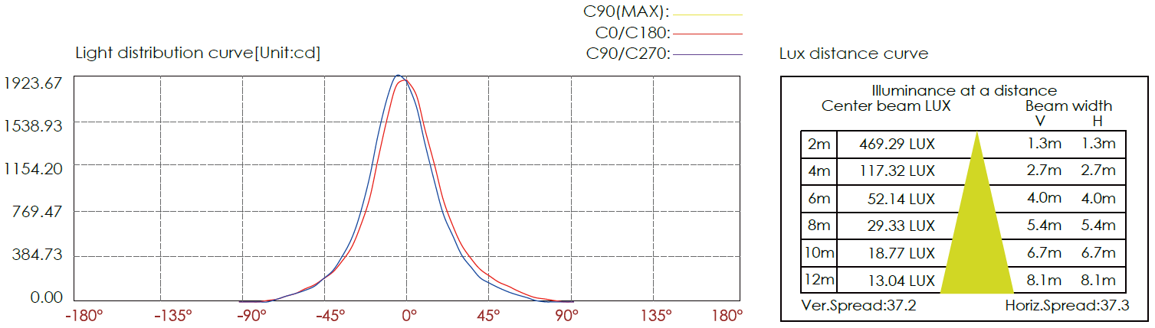

CERTIFICATES


