
Datasheet
No.: R3EJU0126-DC 24-R8-24°
Version: 2025-09-02-01
ITEM: R3EJU0126 | INPUT VOLTAGE(V)  DC 24 | REFLECTOR  R8 | LENS DEGREE(°)θ1/2  24° |  | CCT  3000K
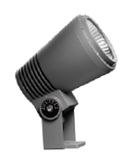  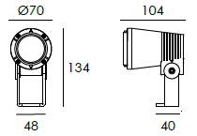 |  | LIGHT SOURCE |  | 1×6W COB
 |  | CONSUMPTION(W) |  | 7.5
 |  | OPERATING CURRENT(MA) |  | 320
 |  | POWER FACTOR(PF) |  | 1
 |  | LUMINANCE(LM) |  | CW=730 WW=646
 |  | COLOR RENDERING INDEX |  | RA: 80
 |  | IK RATING |  | 05
 |  | IP RATING |  | 66
PRODUCT SPECIFICATIONS
HOUSING | 12# Die-casting aluminum finishing or powder painting T=60-80μm.  Adhesion of ISO class 1/ASTM class 4B
LIGHT WINDOW | Tempered glass.T=3mm
LED TYPE | COB
LED DRIVER | Constant Voltage Input, Constant Current Output
CABLE GLAND | IP68 PG-9 PA66
GASKET | Tooling shaped seal
POWER CABLE | Outside of luminaire  12V/24V: H05RN-F 2×1.0mm², L=2.0m
IK | 05
DIMMING SUPPORT | Triac PWM Available 1-10V Dali Customized
WATER PROOF SOLUTION
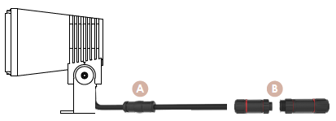
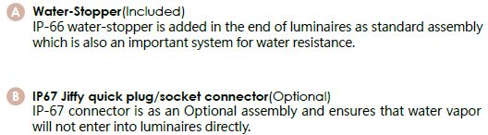

ACCESSORIES(Optional)
SPIKE  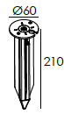  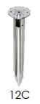  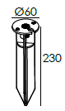  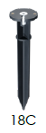  PC/ABS alloys STAINLESS STEEL | 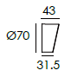  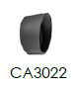  BEVEL CUT HOOD
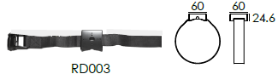
TREE POLE STRAP

PAINTING COLOR
  Regular   |       Secondary      

PHOTOMETRIC
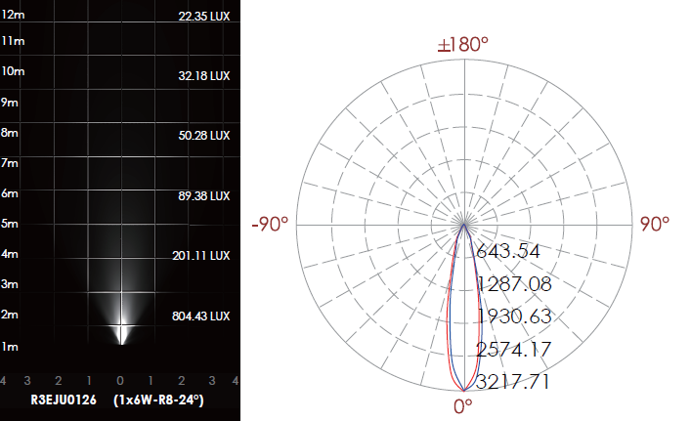

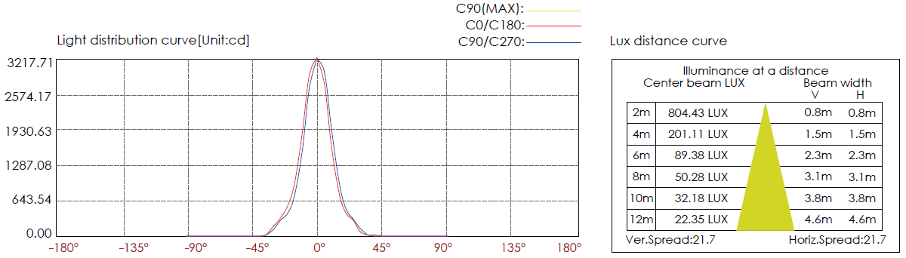

CERTIFICATES





