
Datasheet
No.: D9EDL2434-DC 24
Version: 2025-09-01-01
ITEM: D9EDL2434 | INPUT VOLTAGE(V)  DC 24 | LENS  N/A | LENS DEGREE(°)θ1/2  N/A |  | CCT  3000K
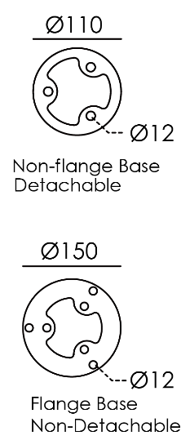  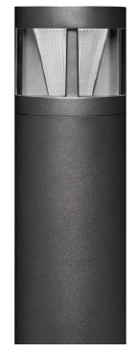  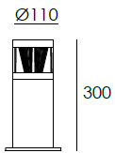 |  | HEIGHT(mm) |  | 300
 |  | LIGHT SOURCE |  | 24×0.2W
 |  | CONSUMPTION(W) |  | 6.0
 |  | OPERATING CURRENT(MA) |  | 250
 |  | POWER FACTOR(PF) |  | 1
 |  | LUMINANCE(LM) |  | 264.5
 |  | COLOR RENDERING INDEX |  | RA: 80
 |  | IK RATING |  | 07
 |  | IP RATING |  | 65
PRODUCT SPECIFICATIONS
HOUSING | T=60-80μm Adhesion of ISO class 1/ASTM class 4B  12# Die-casting powder coated aluminum.
LIGHT WINDOW | PMMA
LED TYPE | SMD
LED DRIVER | Constant Voltage Input, Constant Current Output
POWER CABLE | Outside of luminaire  12V/24V: H05RN-F 2×1.0mm², L=0.5m
BASE | Flange base
DIMMABLE SUPPORT | Triac PWM Available 1-10V Dali Customized
OPERATING TEMPERATURE | -20°C~40°C

BASE OPTIONS
Screw Base | 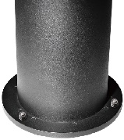   | 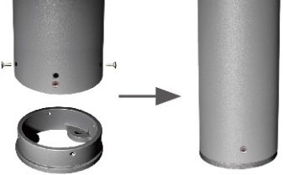  
Inground Base  (Optional) | 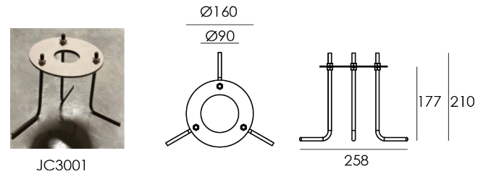 | 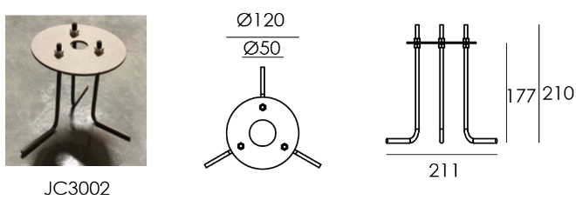
Ground Anchor  Base And  Installationb steps  (Optional) | 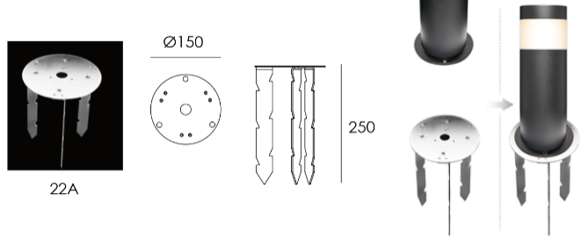 | 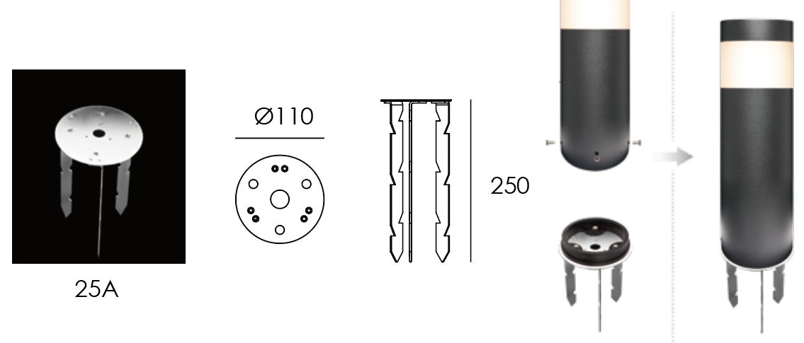

PAINTING COLOR








PHOTOMETRIC
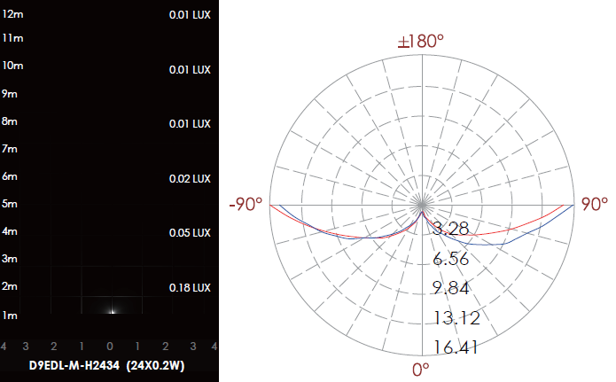

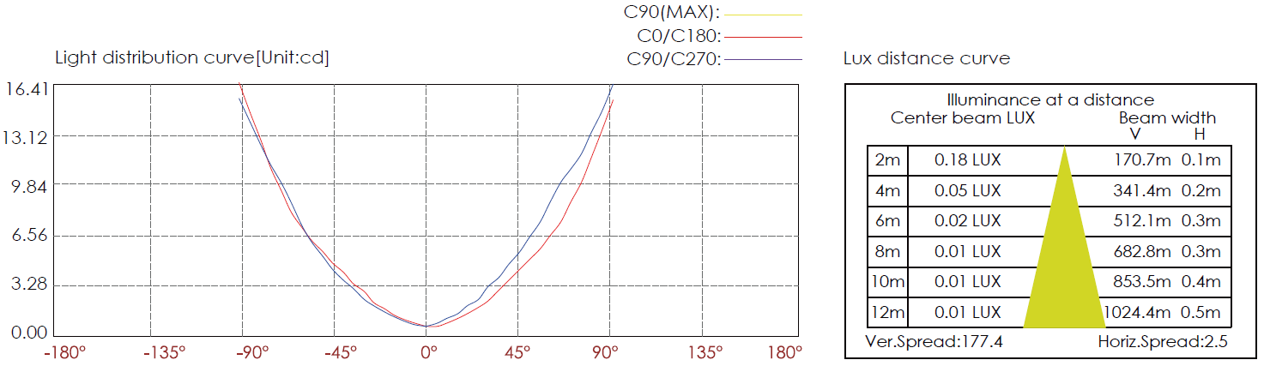

CERTIFICATES





