
Datasheet
No.: XB2KFR0174-120 240-B121-28°
Version: 2025-09-01-01
ITEM: XB2KFR0174 | INPUT VOLTAGE(V)  120 240 | LENS  B121 |  | LENS DEGREE(°)θ1/2  28° |  | CCT  3000K
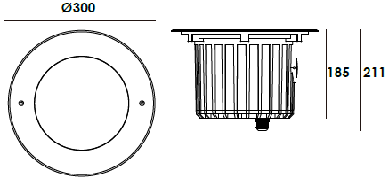  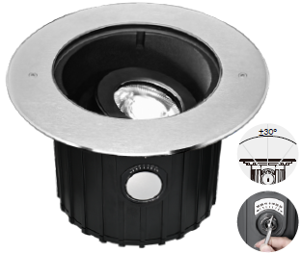 |  |  | LIGHT SOURCE |  | 1×14W
 |  |  | CONSUMPTION(W) |  | 120=28.8 240=33
 |  |  | OPERATING CURRENT(MA) |  | 240=148
 |  |  | POWER FACTOR(PF) |  | 0.881
 |  |  | LUMINANCE(LM) |  | 3100
 |  |  | COLOR RENDERING INDEX |  | RA: 80
 |  |  | IK RATING |  | 10
 |  |  | IP RATING |  | 67
PRODUCT SPECIFICATIONS
HOUSING | 12# Die-casting aluminum powder coated T=60-80μm  Adhesion of ISO class 1/ATM class 4B
FRONT COVER | Hard chrome-plated stainless steel SUS 316L#
LIGHT WINDOW | Tempered step glass.T=10mm
LED TYPE | COB
GLASS PRESSURE CAPACITY | Full Area= 5,356kgs
CABLE GLAND | IP68 PG-13.5PA66
GASKET | Silicon rubber molding shaped seal
LED DRIVER | Constant Voltage Input, Constant Current Output
OPERATING TEMPERATURE | -20˚ C~40˚ C
POWER CABLE | Outside of luminaire  120V/240V: H07RN-F 3×1.0mm², L=0.5m
DIMMING SUPPORT | Triac PWM Available 1-10V Dali Customized
RECESSED SLEEVE MATERIAL | PC/ABS ALLOYS
ACCESSORIES(Optional)
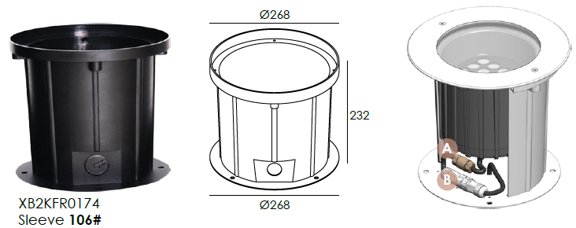  SLEEVE(Included) |  | 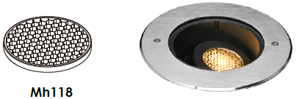  HONEYCOMB LOUVER

WATER PROOF SOLUTION
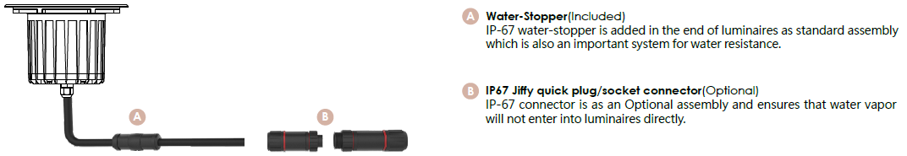

PHOTOMETRIC
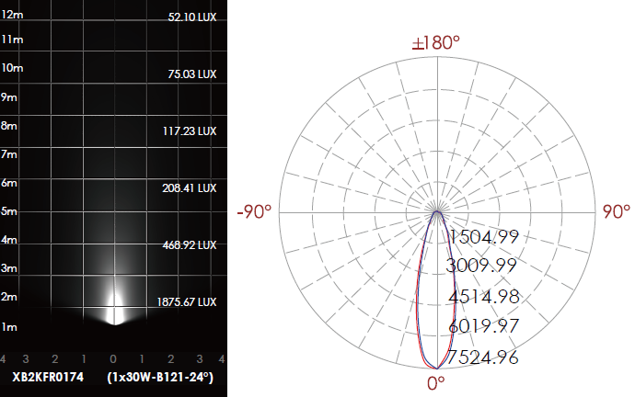

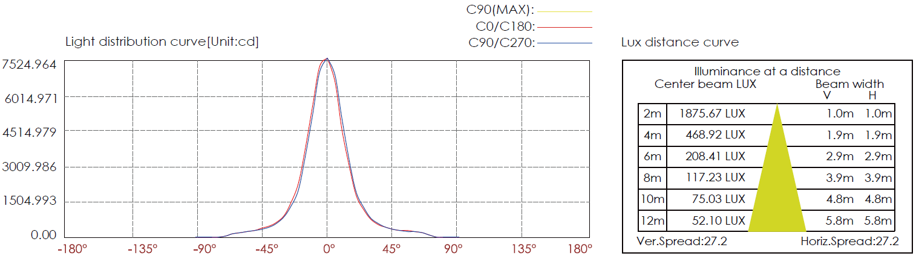

CERTIFICATES


