
Datasheet
No.: D9DYL3034-240
Version: 2025-08-29-01
ITEM: D9DYL3034 | INPUT VOLTAGE(V)  240 | LENS  N/A | LENS DEGREE(°)θ1/2  N/A |  | CCT  3000K
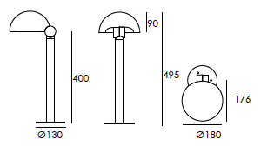  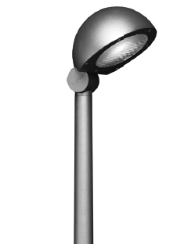 |  | HEIGHT(mm) |  | 495
 |  | LIGHT SOURCE |  | 30×0.5W
 |  | CONSUMPTION(W) |  | 18.5
 |  | OPERATING CURRENT(MA) |  | D770
 |  | POWER FACTOR(PF) |  | 0.866
 |  | LUMINANCE(LM) |  | 2054
 |  | COLOR RENDERING INDEX |  | RA: 80
 |  | IK RATING |  | 05
 |  | IP RATING |  | 65
PRODUCT SPECIFICATIONS
HOUSING | T=60-80μm Adhesion of ISO class 1/ASTM class 4B  12# Die-casting powder coated aluminum.
LIGHT WINDOW | PC
LED TYPE | SMD
LED DRIVER | Constant Voltage Input, Constant Current Output
OPERATING TEMPERATURE | -20°C~40°C
POWER CABLE | Outside of luminaire  120V/240V: H05RN-F 3×1.0mm², L=0.5m
BASE | Flange Base
DIMMING SUPPORT | Triac PWM Available 1-10V Dali Customized
INSTALLATION BASE
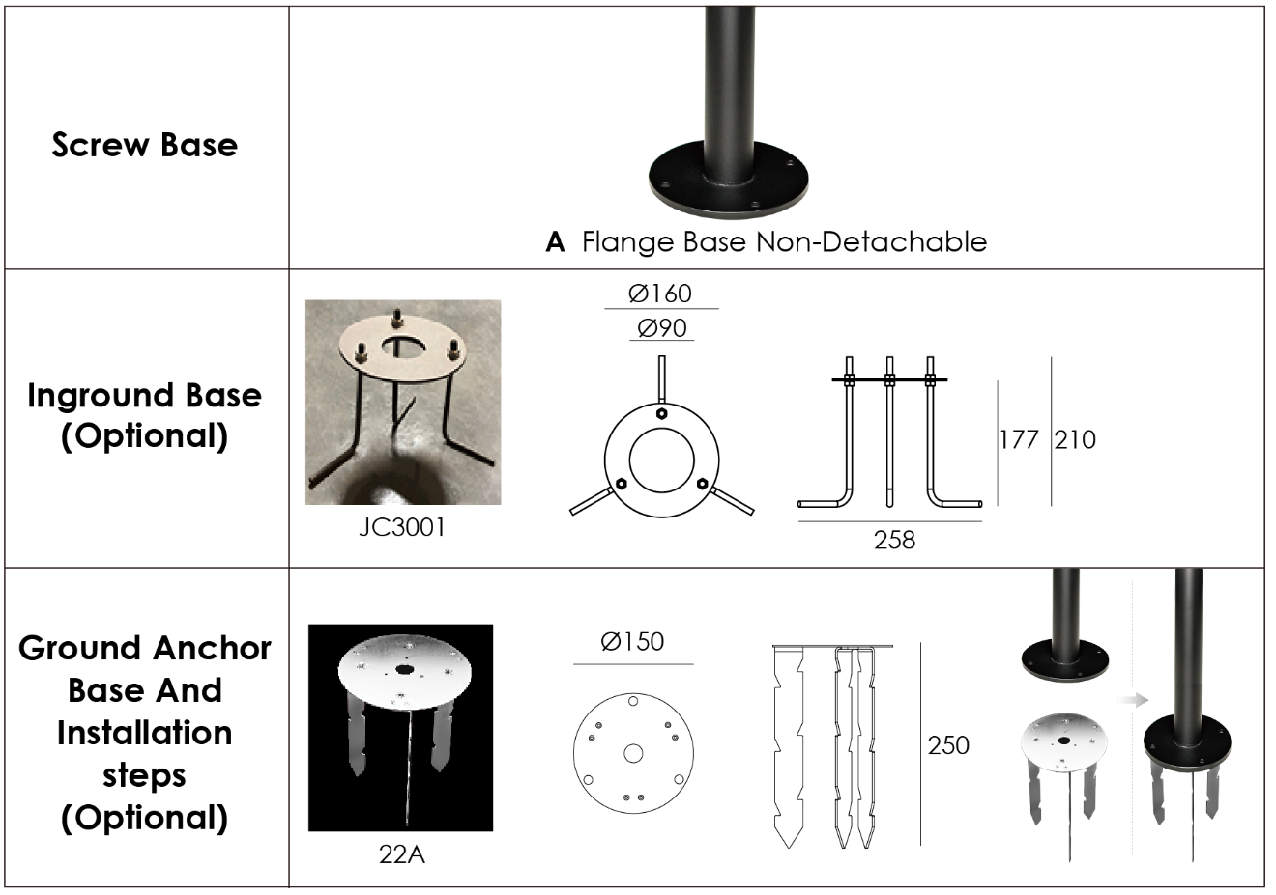

PAINTING COLOR








PHOTOMETRIC
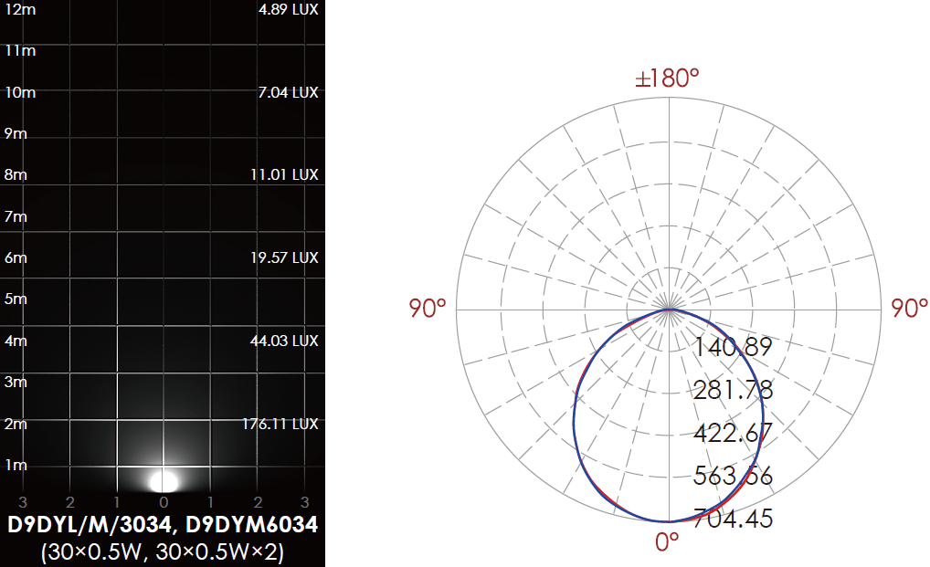

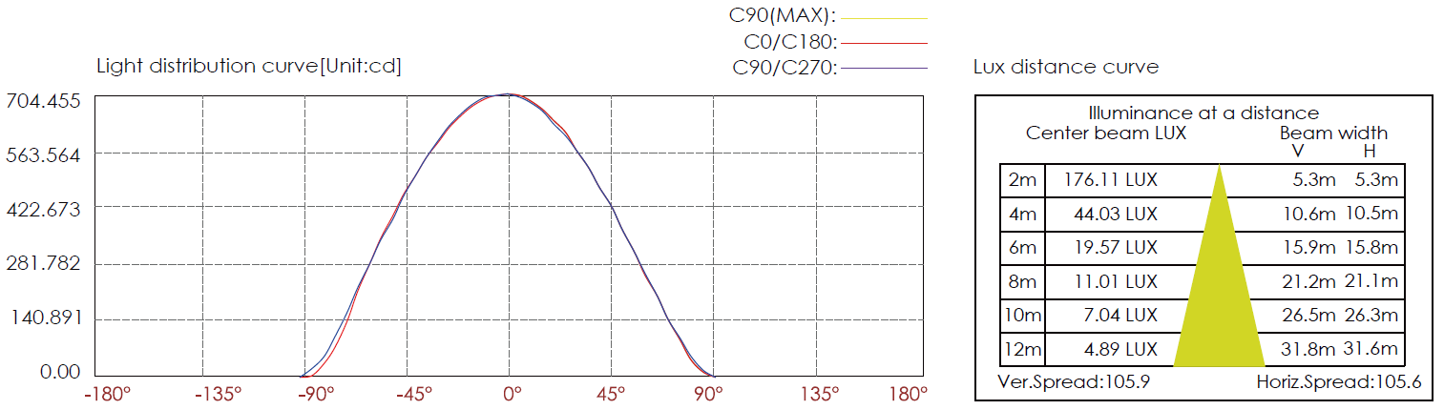

CERTIFICATES





