
Datasheet
No.: D6IE4217-DC 24-120°
Version: 2025-08-28-01
ITEM: D6IE4217 | INPUT VOLTAGE(V)  DC 24 | LENS  N/A | LENS DEGREE(°)θ1/2  120° | CCT  3000K
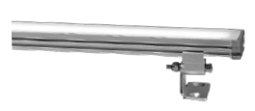  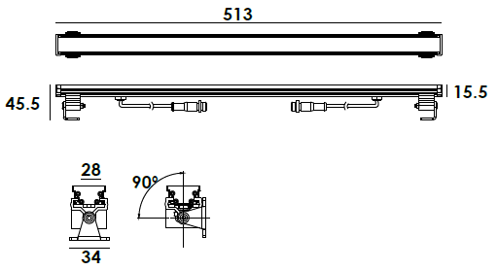 |  | LIGHT SOURCE | 42×0.2W
 |  | LENGTH(MM) | 513
 |  | CONSUMPTION(W) | 8.5
 |  | OPERATING CURRENT(MA) | 350
 |  | POWER FACTOR(PF) | 1
 |  | LUMINANCE(LM) | CW=430 WW=418
 |  | COLOR RENDERING INDEX | RA: 80
 |  | IK RATING | 08
 |  | IP RATING | 65
PRODUCT SPECIFICATIONS
HOUSING | Aluminum anodized finishing &powder painting
LIGHT WINDOW | Tempered frosted glass.T=3mm
CABLE GLAND | Copper and nickel coated
GASKET | Glass and housing are silicone sealed
PCB | Heat conductivity≥2.0w/mk
LED TYPE | SMD
OPERATING TEMPERATURE | -20˚ C~40˚ C
POWER CABLE | H03VV-F 2×0.75mm², L=0.25m
DIMMING SUPPORT | 1-10V Dali Customized
CONNECTION
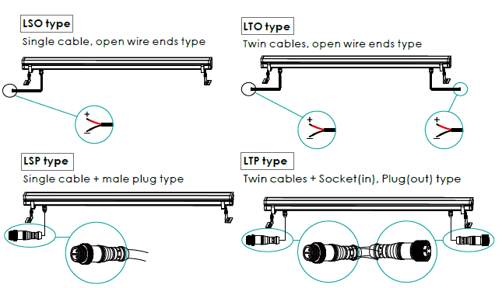

PHOTOMETRIC
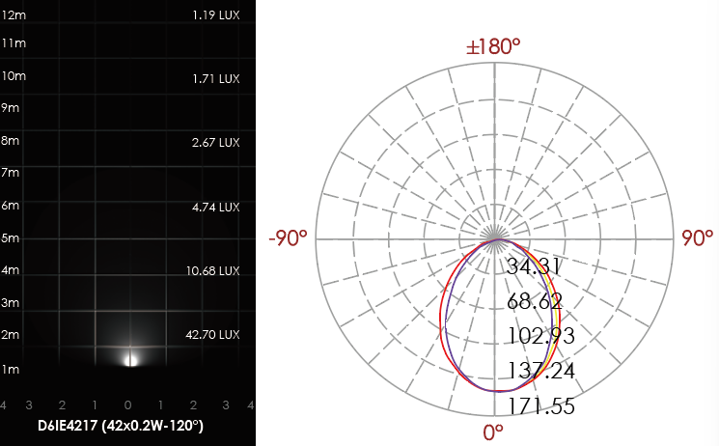

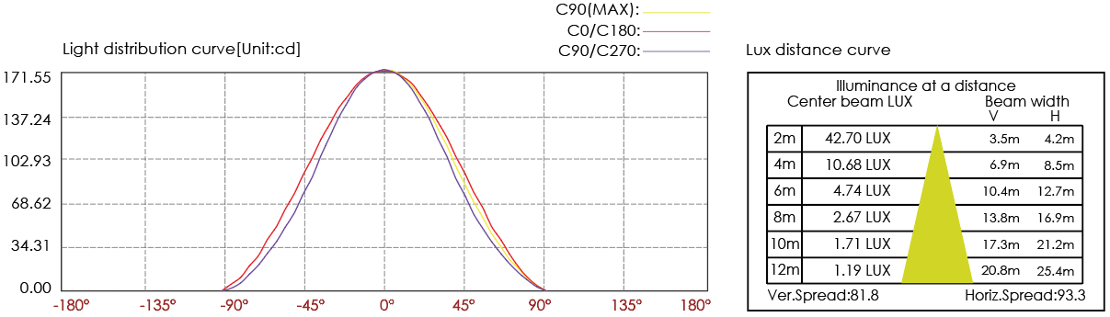

CERTIFICATES


