
Datasheet
No.: RB2CNS0126-DC 24-R8-24°
Version: 2025-08-27-01
ITEM: RB2CNS0126 | INPUT VOLTAGE(V)  DC 24 | REFLECTOR  R8 | LENS DEGREE(°)θ1/2  24° |  | CCT  3000K
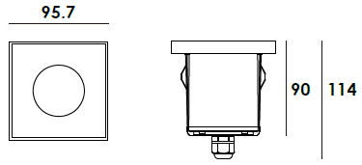  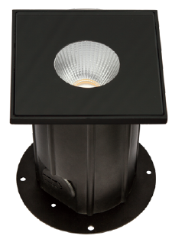 |  | LIGHT SOURCE |  | 1×6W
 |  | CONSUMPTION(W) |  | 7.7
 |  | OPERATING CURRENT(MA) |  | 320
 |  | POWER FACTOR(PF) |  | 1
 |  | LUMINANCE(LM) |  | CW=909 WW=744
 |  | COLOR RENDERING INDEX |  | RA: 80
 |  | IK RATING |  | 06
 |  | IP RATING |  | 67
PRODUCT SPECIFICATIONS
HOUSING | 12# Die-casting aluminum powder coated T=60-80μm.  Adhesion of ISO class 1/ASTM class 4B
LIGHT WINDOW | Tempered step glass.T=4mm
LED TYPE | COB
GLASS PRESSURE CAPACITY | Full area=2,463kgs
REFLECTOR | OPTICS Reflector efficiency≥90%
GASKET | Molding shaped silicone seal
LED DRIVER | Constant Voltage Input,Constant Current Output
OPEARTING TEMPERATURE | -20°C ~40°C
POWER CABLE | Outside of luminaire  12V/24V: H05RN-F 2×1.0mm², L=0.5m
RECESSED SLEEVE | PC/ABS ALLOYS
DIMMING SUPPORT | Triac PWM Available 1-10V Dali Customized
IP | IP67
WATER PROOF SOLUTION
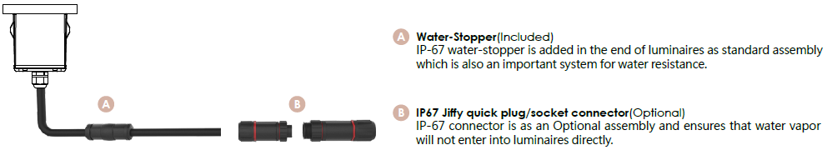

ACCESSORIES(Optional)
SLEEVE  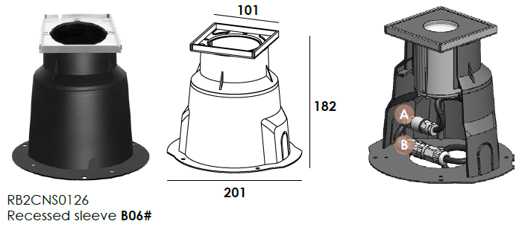  Optional1 | 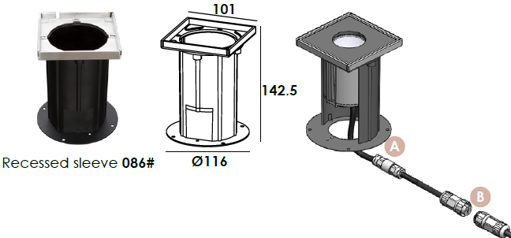  Optional 2

PHOTOMETRIC
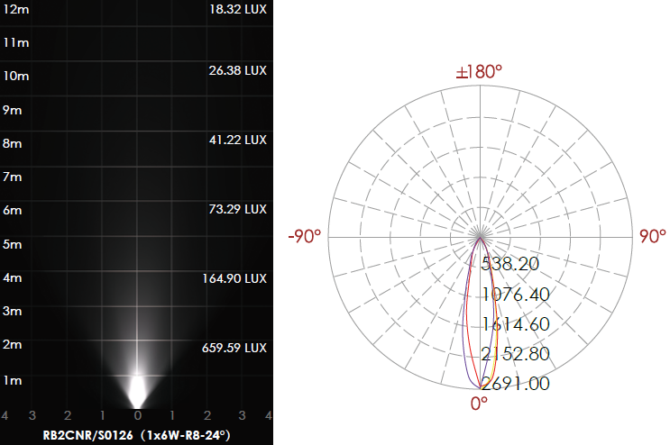

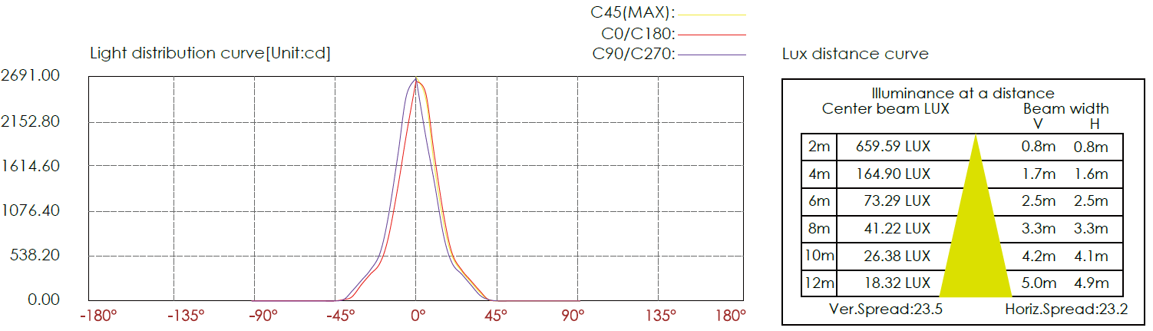

CERTIFICATES



