
Datasheet
No.: 4E2BFS0167-DC 24-B80-40°
Version: 2025-08-25-01
ITEM: 4E2BFS0167 | INPUT VOLTAGE(V)  DC 24 | LENS  B80 | LENS DEGREE(°)θ1/2  40° |  | CCT  3000K
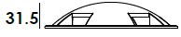  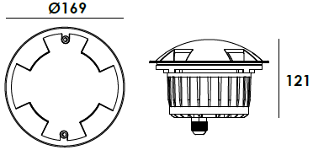  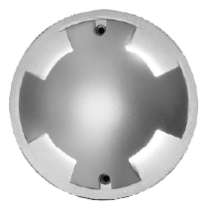 |  | LIGHT SOURCE |  | 1×8.5W
 |  | CONSUMPTION(W) |  | 10
 |  | OPERATING CURRENT(MA) |  | 416
 |  | POWER FACTOR(PF) |  | 1
 |  | LUMINANCE(LM) |  | 168
 |  | COLOR RENDERING INDEX |  | RA: 80
 |  | IK RATING |  | 10
 |  | IP RATING |  | 67
PRODUCT SPECIFICATIONS
HOUSING | 12# Die-casting aluminum powder coated T=60-80μm.  Adhesion of ISO class 1/ASTM class 4B
FRONT COVER | Hard chromeplated stainless steel SUS 316#
LIGHT WINDOW | UVstop & Fireproof PC
LED TYPE | SMD
GASKET | IP68 PG-11 PA66
OPERATING TEMPERATURE | Silicon rubber molding shaped seal
LED DRIVER | Constant Voltage Input,Constant Current Output
POWER CABLE | Outside of luminaire  12V/24V: H07RN-F 2×1.0mm², L=0.5m
RECESSED SLEEVE MATERIAL | PC/ABS ALLOYS
GLASS PRESSURE CAPACITY | >2,000kgs
DIMMING SUPPORT | Triac PWM Available 1-10V Dali Customized
IP | IP67
OPERATING TEMPERATURE | -20˚ C~40˚ C
WATER PROOF SOLUTION
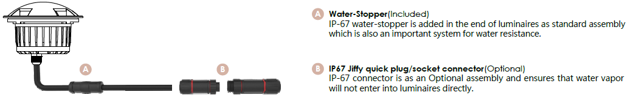

ACCESSORIES(Optional)
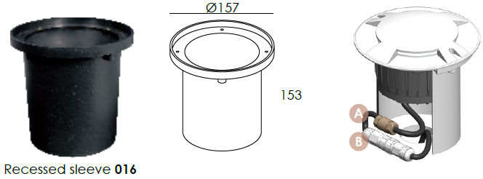
SLEEVE

PHOTOMETRIC
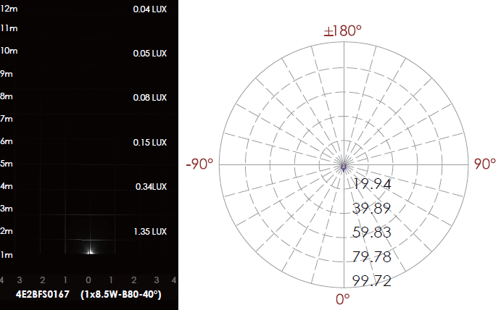

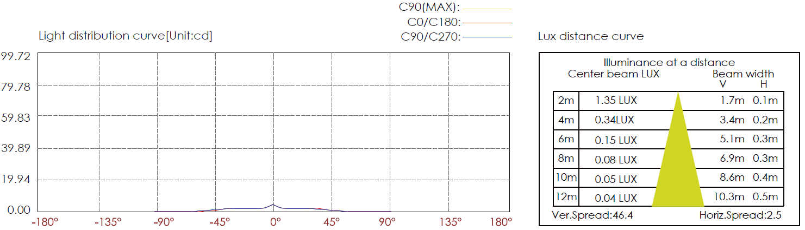

CERTIFICATES



