
Datasheet
No.: R2EFR0129-120 240-R18-22°
Version: 2025-08-19-01
ITEM: R2EFR0129 | INPUT VOLTAGE(V)  120 240 |  | REFLECTOR  R18 | LENS DEGREE(°)θ1/2  22° |  | CCT  3000K
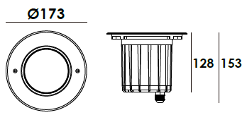  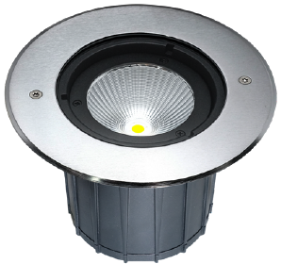 |  |  | LIGHT SOURCE |  | 1×12W
 |  |  | CONSUMPTION(W) |  | 120=14 240=14
 |  |  | OPERATING CURRENT(MA) |  | 120=102 240=64
 |  |  | POWER FACTOR(PF) |  | 0.919
 |  |  | LUMINANCE(LM) |  | CW=1436 WW=1389
 |  |  | COLOR RENDERING INDEX |  | RA: 80
 |  |  | IK RATING |  | 09
 |  |  | IP RATING |  | 67
PRODUCT SPECIFICATIONS
HOUSING | 12# Die-casting aluminum dark grey powder coated T=60-80μm  Adhesion of ISO class 1/ATM class 4B
FRONT COVER | Hard chrome-plated stainless steel SUS 316L#
LIGHT WINDOW | Tempered step glass.T=8mm
REFLECTOR | OPTICS Reflector efficiency≥90%
LED TYPE | COB
GLASS PRESSURE CAPACITY | Full Area=2,621kgs
CABLE GLAND | IP68 PG-11 PA66
GASKET | Silicon rubber molding shaped seal
LED DRIVER | Constant Voltage Input, Constant Current Output
OPERATING TEMPERATURE | -20˚ C~40˚ C
POWER CABLE | Outside of luminaire  120V/240V: H07RN-F 3×1.0mm², L=0.5m
DIMMING SUPPORT | Triac PWM Available  1-10V Dali Customized
RECESSED SLEEVE MATERIAL | PC/ABS ALLOYS
ACCESSORIES(Optional)
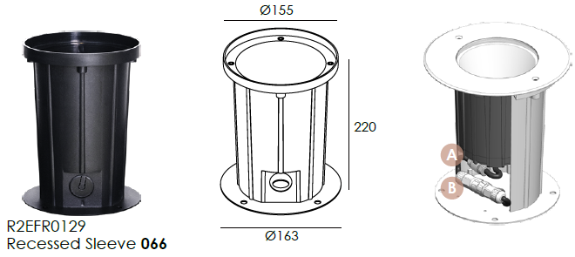  SLEEVE |  | 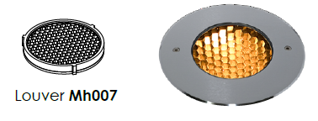  HONEYCOMB LOUVER (Optional)

WATER PROOF SOLUTION
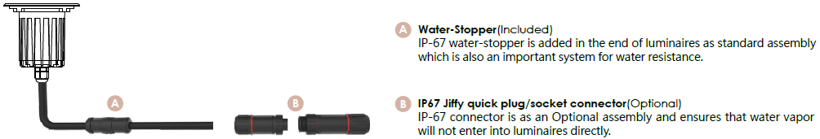

PHOTOMETRIC
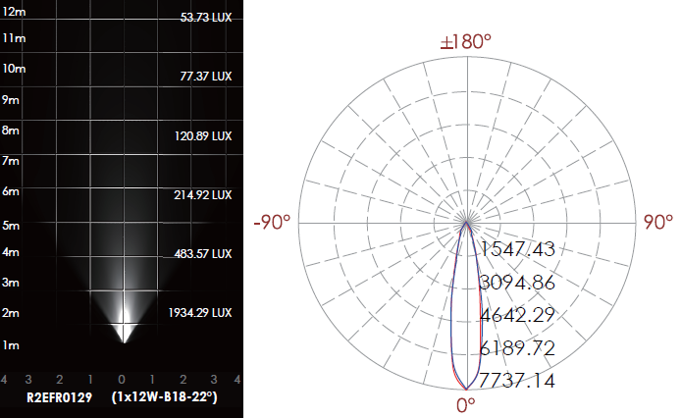

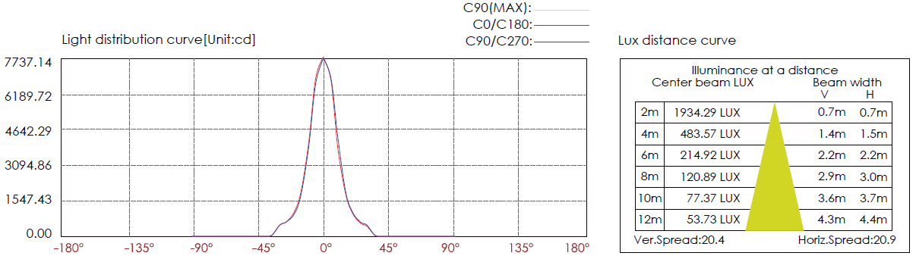

CERTIFICATES


