
Datasheet
No.: R2CFR0125-120 240-R7-24°
Version: 2025-08-19-01
ITEM: R2CFR0125 | INPUT VOLTAGE(V)  120 240 |  | REFLECTOR  R7 | LENS DEGREE(°)θ1/2  24° |  | CCT  3000K
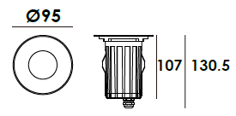  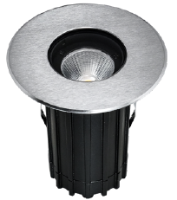 |  |  | LIGHT SOURCE |  | 1×5W
 |  |  | CONSUMPTION(W) |  | 120=6.4 240=6.5
 |  |  | OPERATING CURRENT(MA) |  | 120=88 240=50
 |  |  | POWER FACTOR(PF) |  | 0.833
 |  |  | LUMINANCE(LM) |  | CW=555 WW=441
 |  |  | COLOR RENDERING INDEX |  | RA: 80
 |  |  | IK RATING |  | 08
 |  |  | IP RATING |  | 67
PRODUCT SPECIFICATIONS
HOUSING | 12# Die-casting aluminum dark grey powder coated T=60-80μm  Adhesion of ISO class 1/ATM class 4B
FRONT COVER | Hard chrome-plated stainless steel SUS 316L#
LIGHT WINDOW | Tempered step glass.T=6mm
REFLECTOR | OPTICS Reflector efficiency≥90%
LED TYPE | COB
GLASS PRESSURE CAPACITY | Full Area=1,195kgs
CABLE GLAND | IP68 PG-9 PA66
GASKET | Silicon rubber molding shaped seal
LED DRIVER | Constant Voltage Input, Constant Current Output
OPERATING TEMPERATURE | -20˚ C~40˚ C
POWER CABLE | Outside of luminaire  120V/240V: H05RN-F 3×1.0mm², L=0.5m
DIMMING SUPPORT | Triac PWM Available  1-10V Dali Customized
RECESSED SLEEVE MATERIAL | PC/ABS ALLOYS
ACCESSORIES(Optional)
SLEEVE  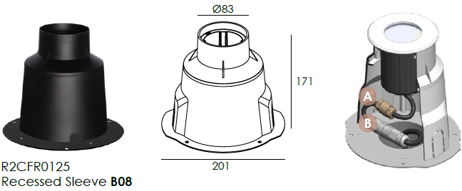  Optional1 |  | 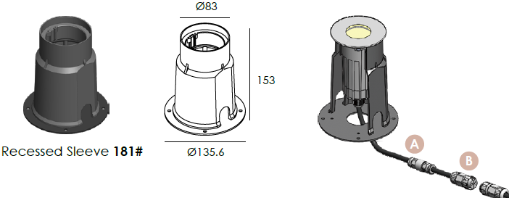  Optional 2
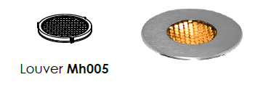
HONEYCOMB LOUVER (Optional)

WATER PROOF SOLUTION
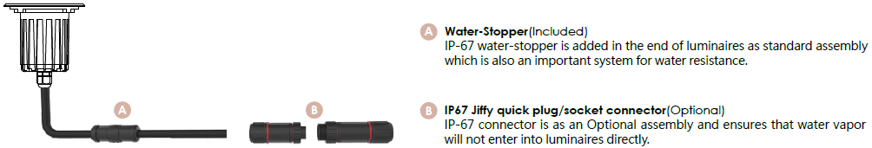

PHOTOMETRIC
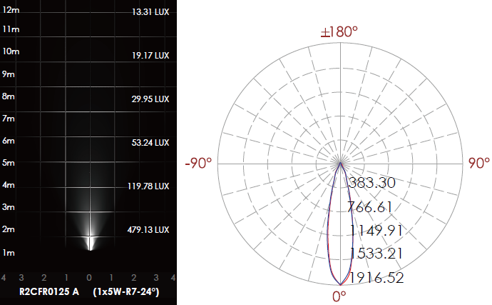

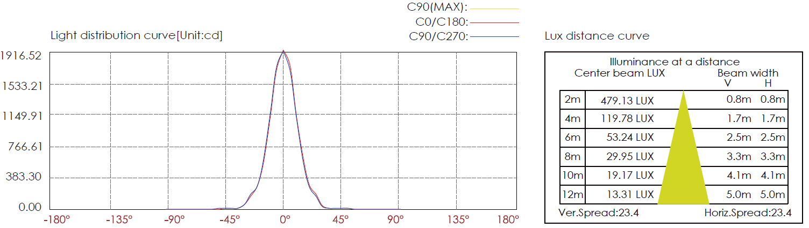

CERTIFICATES


