
Datasheet
No.: FC2CDR0357-120 240-FC03-45°x35°
Version: 2025-08-19-01
ITEM: FC2CDR0357 | INPUT VOLTAGE(V)  120 240 | LENS  FC03 | LENS DEGREE(°)θ1/2  45°x35° |  | CCT  3000K
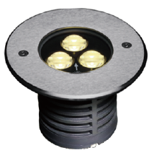  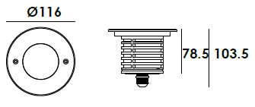 |  | LIGHT SOURCE |  | 3×2W
 |  | CONSUMPTION(W) |  | 120=6.0 240=6.0
 |  | OPERATING CURRENT(MA) |  | 120=51 240=30
 |  | POWER FACTOR(PF) |  | 0.89
 |  | LUMINANCE(LM) |  | CW=398 WW=359
 |  | COLOR RENDERING INDEX |  | RA: 80
 |  | IK RATING |  | 08
 |  | IP RATING |  | 67
PRODUCT SPECIFICATIONS
HOUSING | 12# Diecasting aluminum powder coated T=60-80μm
FRONT RING | Hard chromeplated Stainless steel SUS 316L#
LIGHT WINDOW | Tempered step glass.T=8mm
CABLE GLAND | IP68 PG-9 PA66
LED TYPE | SMD
PCB | Excellent heat conductivity aluminum coefficient of  heat Conductivity≥2.0w/mk
LED DRIVER | Constant Voltage Input, Constant Current Output
LENS | OPTICS Reflector efficiency≥85%
OPERATING TEMPERATURE | -20˚ C~40˚ C
POWER CABLE | Outside of luminaire  120V/240V: H05RN-F 3×1.0mm², L=0.5m
RECESSED SLEEVE MATERIAL | PC/ABS ALLOYS
GLASS PRESSURE CAPACITY | 2,578kgs
DIMMING SUPPORT | Triac PWM Available 1-10V Dali Customized
IP | IP67
WATER PROOF SOLUTION
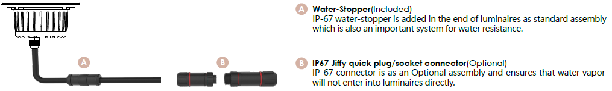

ACCESSORIES(Optional)
SLEEVE  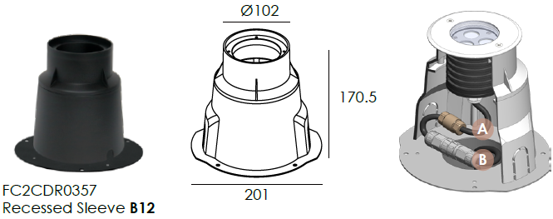  Optional1 | 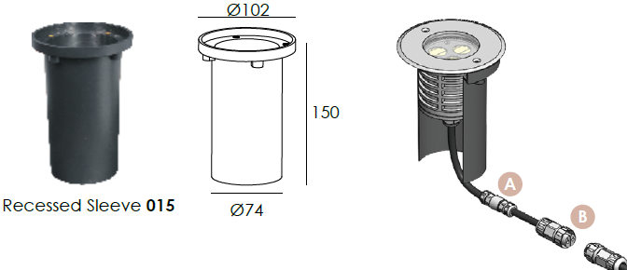  Optional2

PHOTOMETRIC
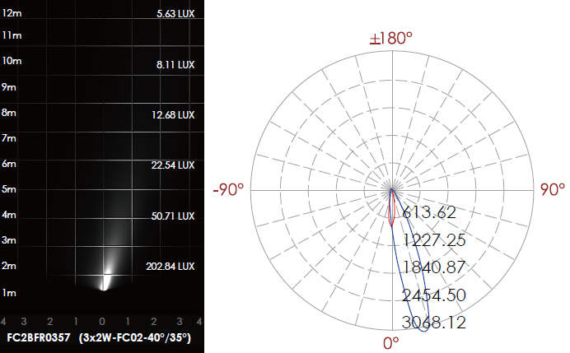

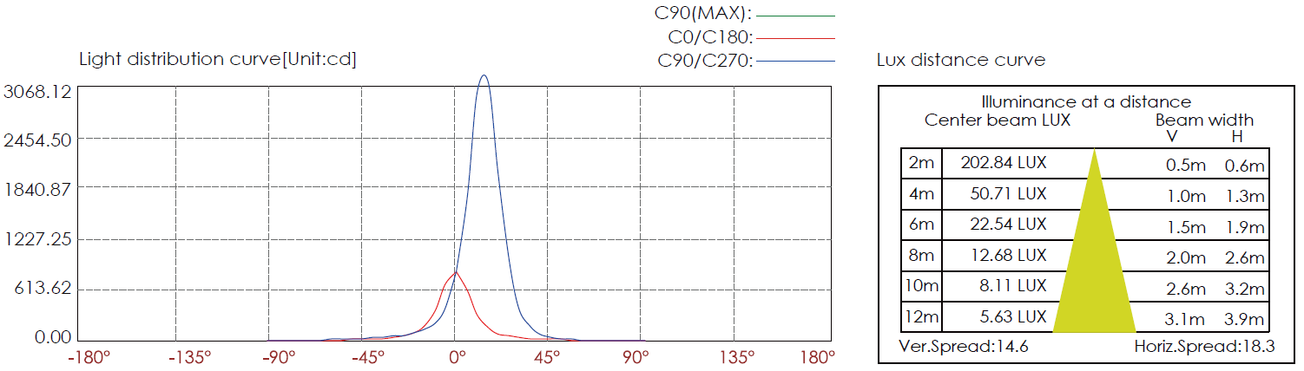

CERTIFICATES



