
Datasheet
No.: B2WDR0157PG-120 240-B73-30°
Version: 2025-08-19-01
ITEM: B2WDR0157PG | INPUT VOLTAGE(V)  120 240 |  | LENS  B73 | LENS DEGREE(°)θ1/2  30° |  | CCT  3000K
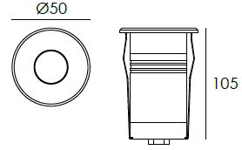  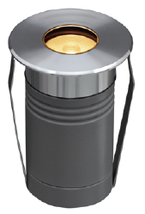 |  |  | LIGHT SOURCE |  | 1×2W
 |  |  | CONSUMPTION(W) |  | 120=2.7 240=2.9
 |  |  | OPERATING CURRENT(MA) |  | 120=41 240=23
 |  |  | POWER FACTOR(PF) |  | 0.476
 |  |  | LUMINANCE(LM) |  | CW=183 WW=143
 |  |  | COLOR RENDERING INDEX |  | RA: 80
 |  |  | IK RATING |  | 08
 |  |  | IP RATING |  | 67
PRODUCT SPECIFICATIONS
FRONT COVER | 316# stainless steel forge molding with hard chromeplated
HOUSING | Die-casting aluminum powder coated T=60-80μm.  Adhesion of ISO class 1/ASTM class 4B
LIGHT WINDOW | Tempered step glass.T=8mm
GASKET | Silicon rubber molding shaped seal
POWER CABLE | Outside of luminaire  120V/240V: H05RN-F 3×1.0mm², L=0.5m
CABLE GLAND | IP67 Copper and nicked coated
LED TYPE | SMD
LED DRIVER | Constant Voltage Input, Constant Current Output
LENS | OPTICS Reflector efficiency≥85%
RECESSED SLEEVE MATERIAL | PC/ABS ALLOYS
GLASS PRESSURE CAPACITY | Full area=1,704kgs
DIMMING SUPPORT | Triac PWM Available 1-10V Dali Customized
IP | IP67
OPERATING TEMPERATURE | -20 ˚ C~40˚ C
ACCESSORIES(Optional)
SLEEVE  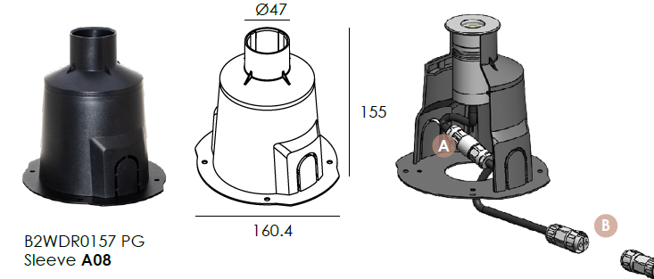  Optional 1 |  | 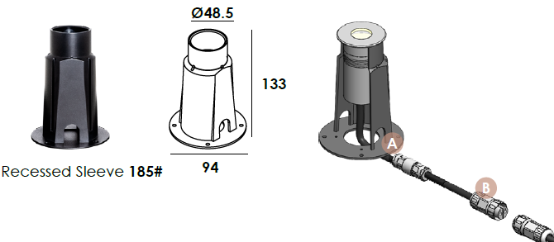  Optional 2
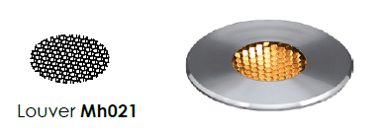
HONEYCOMB LOUVER (Optional)

WATER PROOF SOLUTION
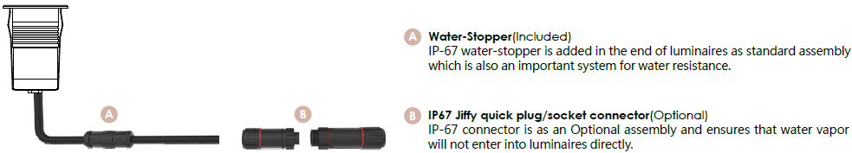

PHOTOMETRIC
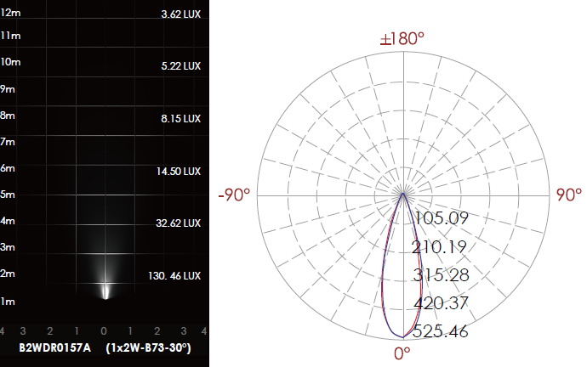

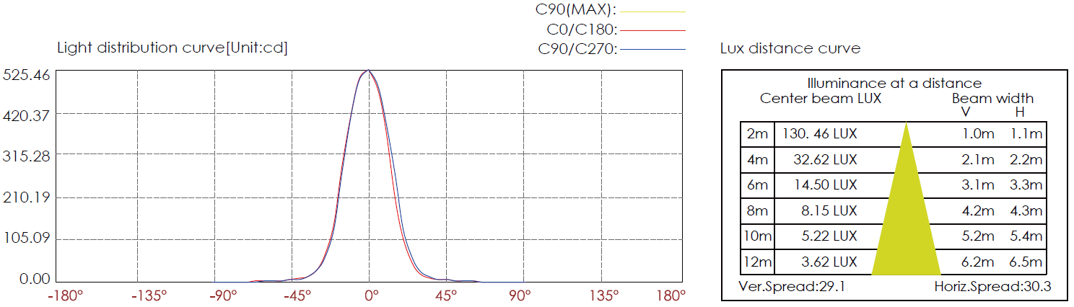

CERTIFICATES


