
Datasheet
No.: 1E2WP0157 PG-120 240-B73-120°
Version: 2025-08-19-01
ITEM: 1E2WP0157 PG | INPUT VOLTAGE(V)  120 240 | LENS  B73 | LENS DEGREE(°)θ1/2  120° |  | CCT  3000K
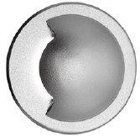  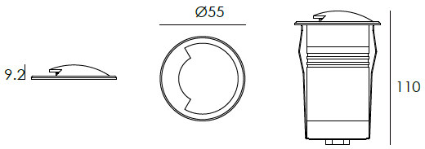 |  | LIGHT SOURCE |  | 1×2W
 |  | CONSUMPTION(W) |  | 120=3.1 240=3
 |  | OPERATING CURRENT(MA) |  | 120=48 240=28
 |  | POWER FACTOR(PF) |  | 0.496
 |  | LUMINANCE(LM) |  | CW=15 WW=13
 |  | COLOR RENDERING INDEX |  | RA: 80
 |  | IK RATING |  | 10
 |  | IP RATING |  | 67
PRODUCT SPECIFICATIONS
HOUSING | ADC12# powder coated aluminum T=60-80μm.  Adhesion of ISO class 1/ASTM class 4B
FRONT COVER | Hard chromeplated stainless steel SUS 316#
LIGHT WINDOW | UVstop & Fireproof PC
GASKET | Silicon rubber molding shaped seal
OPERATING TEMPERATURE | -20˚ C~40˚ C
POWER CABLE | Outside of luminaire  120V/240V: H05RN-F 3×1.0mm², L=0.5m
LED TYPE | SMD
RECESSED SLEEVE MATERIAL | PC/ABS ALLOYS
GLASS PRESSURE CAPACITY | >2,000kgs
DIMMING SUPPORT | Triac PWM Available 1-10V Dali Customized
IP | IP67
WATER PROOF SOLUTION
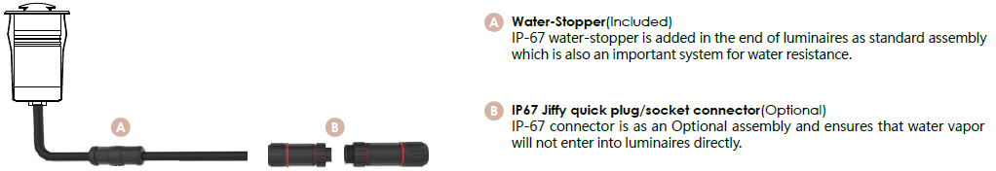

ACCESSORIES(Optional)
SLEEVE  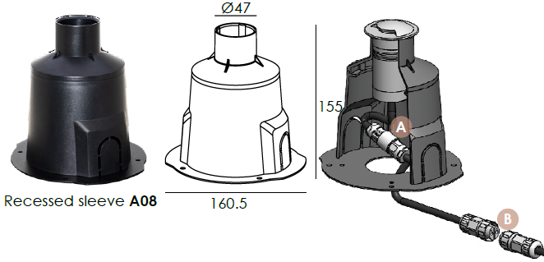  Optional1 | 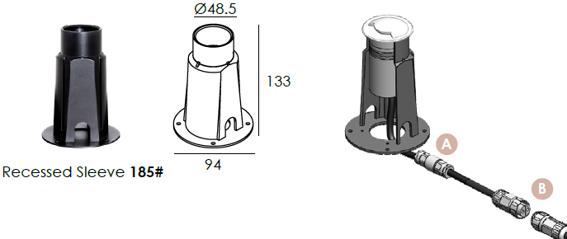  Optional2

PHOTOMETRIC
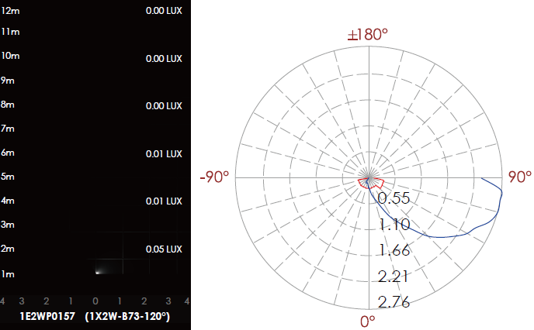

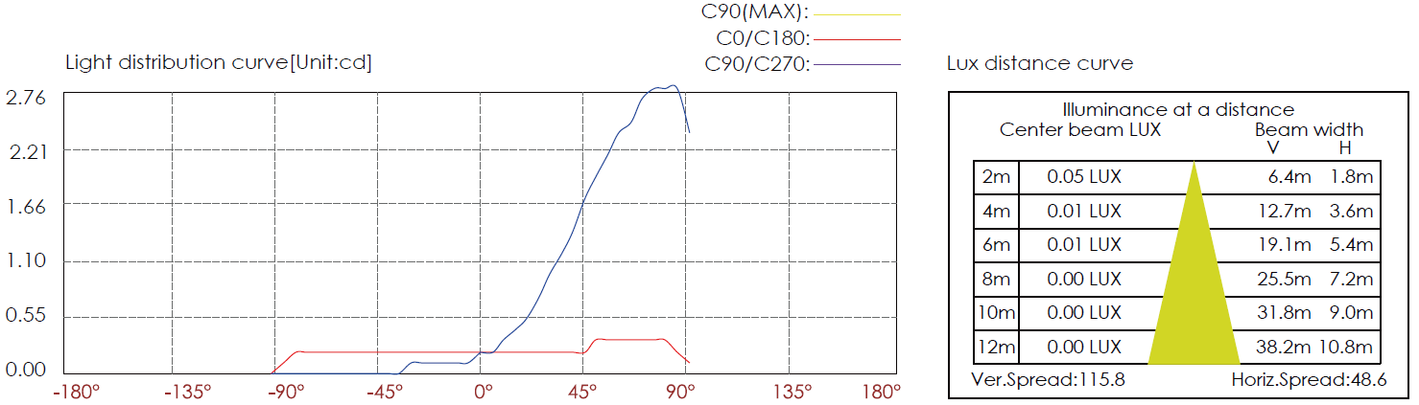

CERTIFICATES



