
Datasheet
No.: B6IE2434-240-B38-40°
Version: 2025-08-19-01
ITEM: B6IE2434 | INPUT VOLTAGE(V)  240 | LENS  B38 | LENS DEGREE(°)θ1/2  40° |  | CCT  3000K
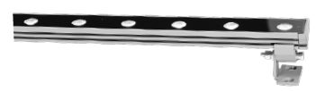  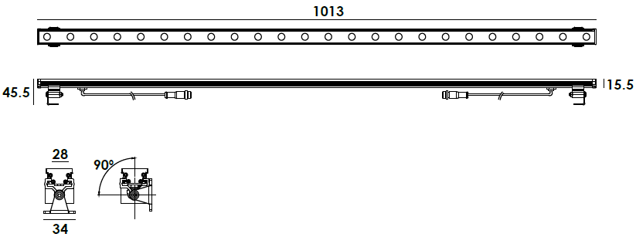 |  | LIGHT SOURCE |  | 24×0.5W
 |  | LENGTH(MM) |  | 1013
 |  | CONSUMPTION(W) |  | 240=17
 |  | OPERATING CURRENT(MA) |  | 240=118
 |  | POWER FACTOR(PF) |  | 1
 |  | LUMINANCE(LM) |  | CW=1114 WW=1020
 |  | COLOR RENDERING INDEX |  | RA: 80
 |  | IK RATING |  | 02
 |  | IP RATING |  | 65
PRODUCT SPECIFICATIONS
HOUSING | Extruded aluminum
BRACKET | Aluminum anodized finishing
LIGHT WINDOW | Tempered glass.T=3mm
CABLE GLAND | Copper IP-65 PG-7
GASKET | Glass and housing are silicone sealed
LENS | OPTICS lens, efficiency≥85%
LED TYPE | SMD
OPERATING TEMPERATURE | -20˚ C~40˚ C
POWER CABLE | H03VV-F 2×0.75mm², L=0.2m  With plug /socket connector  MAX capacity of current=5A
DIMMING SUPPORT | 1-10V Dali Customized
CONNECTION
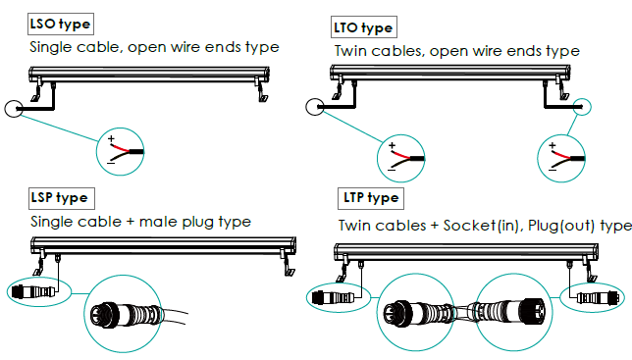

PHOTOMETRIC
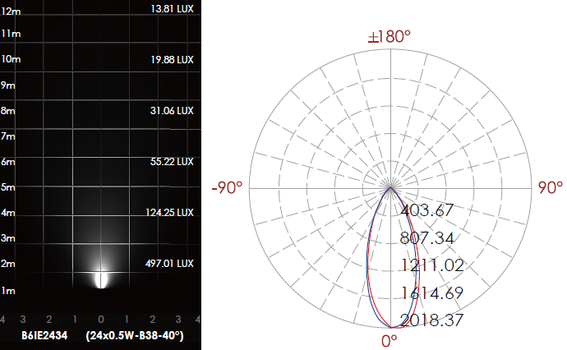

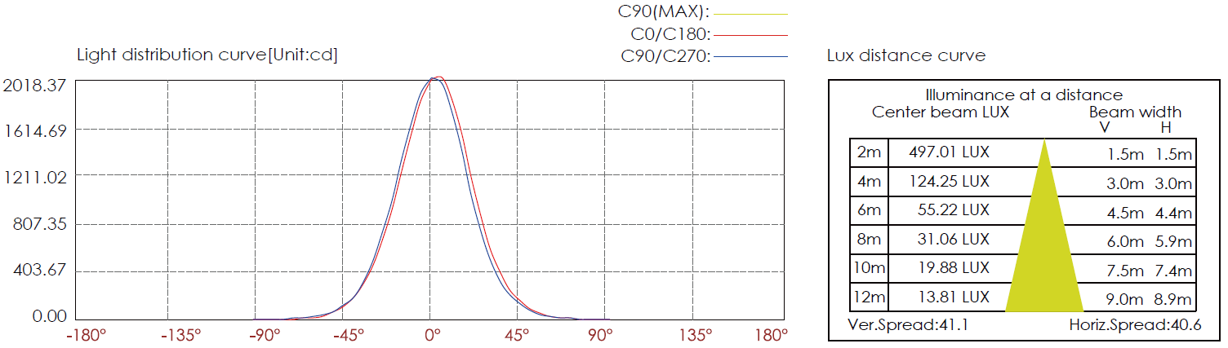

CERTIFICATES


